OudhTrade
Database Design
Module 3 — Roles, Profiles & Verification · M03-5
Document details
Company | MRIDA INFRA AND PLANTATIONS LLP
Product | OudhTrade — oudhtrade.com
Document | M03-5 Database Design
Module | M03 Roles, Profiles & Verification (release R1; some items R2)
Readers | Backend developers, DBA, tech lead
Related documents | PRD (PRD-ROL, PRD-IDN) · HLD · NFR · M02 · other M03 documents
Owner | Tech lead
Decision owner | T. Satish Reddy, CEO & Founder
Status | Draft for review — 24 September 2026
Classification | Confidential — for partners and the OudhTrade team

Contents
1. Overview 3
1.1 Standard columns 3
1.2 Data sensitivity 3
1.3 How to read the table diagrams 4
2. Profiles, Roles and Names 5
2.1 profiles 5
2.2 profile_members 7
2.3 role_assignments 8
2.4 role_change_requests 8
2.5 name_history 9
2.6 profile_translations 10
3. Business Details and Locations 11
3.1 country_id_rules 11
3.2 business_registrations 12
3.3 authorised_persons 14
3.4 compliance_declarations 14
3.5 profile_addresses 15
3.6 profile_contacts 16
4. Verification, Identity Checks and Badges 17
4.1 document_checklists 17
4.2 verification_cases 18
4.3 verification_documents 20
4.4 identity_checks 21
4.5 verification_consents 23
4.6 badges 24
4.7 badge_types 24
5. Enhanced Check and Sanctions 25
5.1 enhanced_checks 25
5.2 beneficial_owners 26
5.3 sanctions_screenings 27
6. Farmers, Field Agents, FPOs and Partners 28
6.1 farm_profiles 28
6.2 farm_visits 30
6.3 field_agents 30
6.4 agent_quality_checks 31
6.5 fpo_memberships 32
6.6 partners 32
7. Declared Supply, Labs and Service Capability 33
7.1 supply_declarations 33
7.2 lab_accreditations 34
7.3 service_capabilities 34
8. Profile Extras, Drafts and Reminders 35
8.1 profile_interests 35
8.2 profile_links 36
8.3 profile_drafts 36
8.4 setup_reminders 37
9. Links to Other Modules 38
10. Retention Summary 39
11. Rules 40
12. Indexes and Volumes 40
13. What Lives Elsewhere 42

1. Overview
Module 3 has 35 tables in PostgreSQL in a schema named `profile` (the names are fixed in the Master Database Design, Section 11.3). Other modules refer to them only by ID through Module 3 interfaces (M03-3 Section 3). Tables follow the Master Database Design standards (naming, IDs, data types, partitioning). All IDs are UUID version 7 (time-ordered). No Module 3 table is partitioned: the largest (verification_documents, setup_reminders, profile_drafts) stay well under a million rows in year 1 (Section 12).
Module 3 holds the profile — the face of an account on the marketplace — and everything needed to trust it: roles, business details, registrations, locations, identity checks, verification cases and documents, badges, service capability, the enhanced check, farm and FPO records, declarations, drafts and reminders. It does not hold accounts, passwords, sign-in consents or delegations (Module 2), or the files themselves (Module 1). Section 13 lists what lives elsewhere.

1.1 Standard columns
Columns | On which Module 3 tables
created_at / created_by | All tables (append-only tables — compliance_declarations, verification_consents, name_history, sanctions_screenings — have created_at only, or their own time column)
updated_at / updated_by | All tables whose rows change
row_version | Tables edited by users or staff: profiles, role_change_requests, business_registrations, authorised_persons, profile_addresses, profile_contacts, verification_cases, verification_documents, identity_checks, enhanced_checks, beneficial_owners, badges, farm_profiles, farm_visits, field_agents, agent_quality_checks, fpo_memberships, partners, supply_declarations, lab_accreditations, service_capabilities, profile_links, country_id_rules, document_checklists, badge_types
anonymised_at | profiles, authorised_persons, profile_addresses, profile_contacts, identity_checks, beneficial_owners, farm_profiles, fpo_memberships (set when the account is anonymised after closure)
active / version | country_id_rules, document_checklists, badge_types (reference data: versioned and retired, never deleted)

Standard columns are not repeated in the tables below unless a table uses them in a special way. `created_by` and `updated_by` hold an account, staff user or fixed system ID (Master Database Design, Section 4.3).

1.2 Data sensitivity
Each table below has a Data level note with its level from NFR, Security & Compliance, Section 6.5 (Public, Internal, Confidential, Restricted). Where a table mixes levels, the note names the columns at the higher level. Module 3 holds much Restricted data: government ID and document numbers, verification documents, identity-check results and face-match scores, and map pins. These columns are encrypted at field level (bytea) with a keyed hash or masked copy for lookup, are never sent to AI services (the only exception is the reviewer translation, with numbers removed first — NFR 6.5, M03-3 Section 7) and are never shown to Support. Aadhaar numbers, Aadhaar XML and Aadhaar photos are never stored anywhere — only the last 4 digits, the result and the provider reference (M03-2 IDV-002). Selfies are never stored in these tables and their files are deleted right after the check (M03-2 DAT-007).
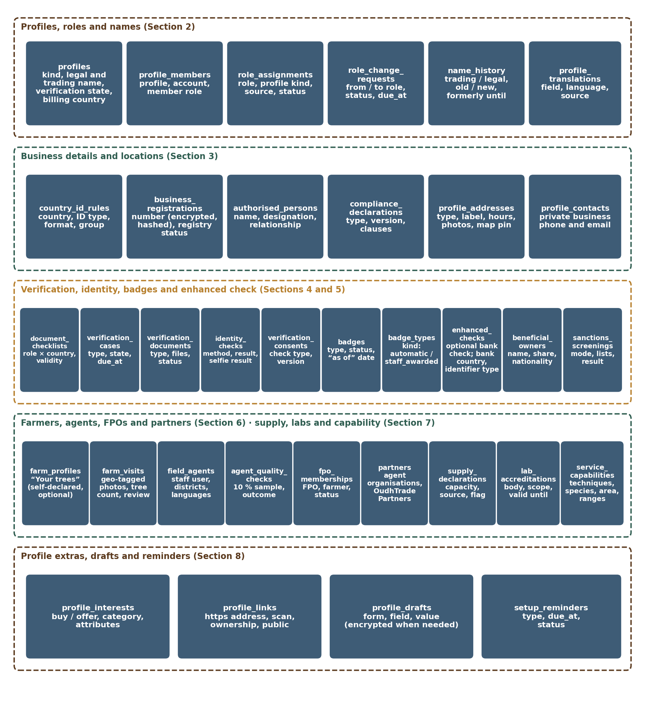
Figure 1 — Module 3 data model (overview)

1.3 How to read the table diagrams
The marks used in the table diagrams (PK, FK, ref, one / many, optional / required, dashed lines) are explained in the diagram key of the Master Database Design, Section 1.3. Diagrams show the main columns; the full column list is in each table below. A grey dashed table belongs to another module; a short table with “…” is shown in full in another section.

2. Profiles, Roles and Names
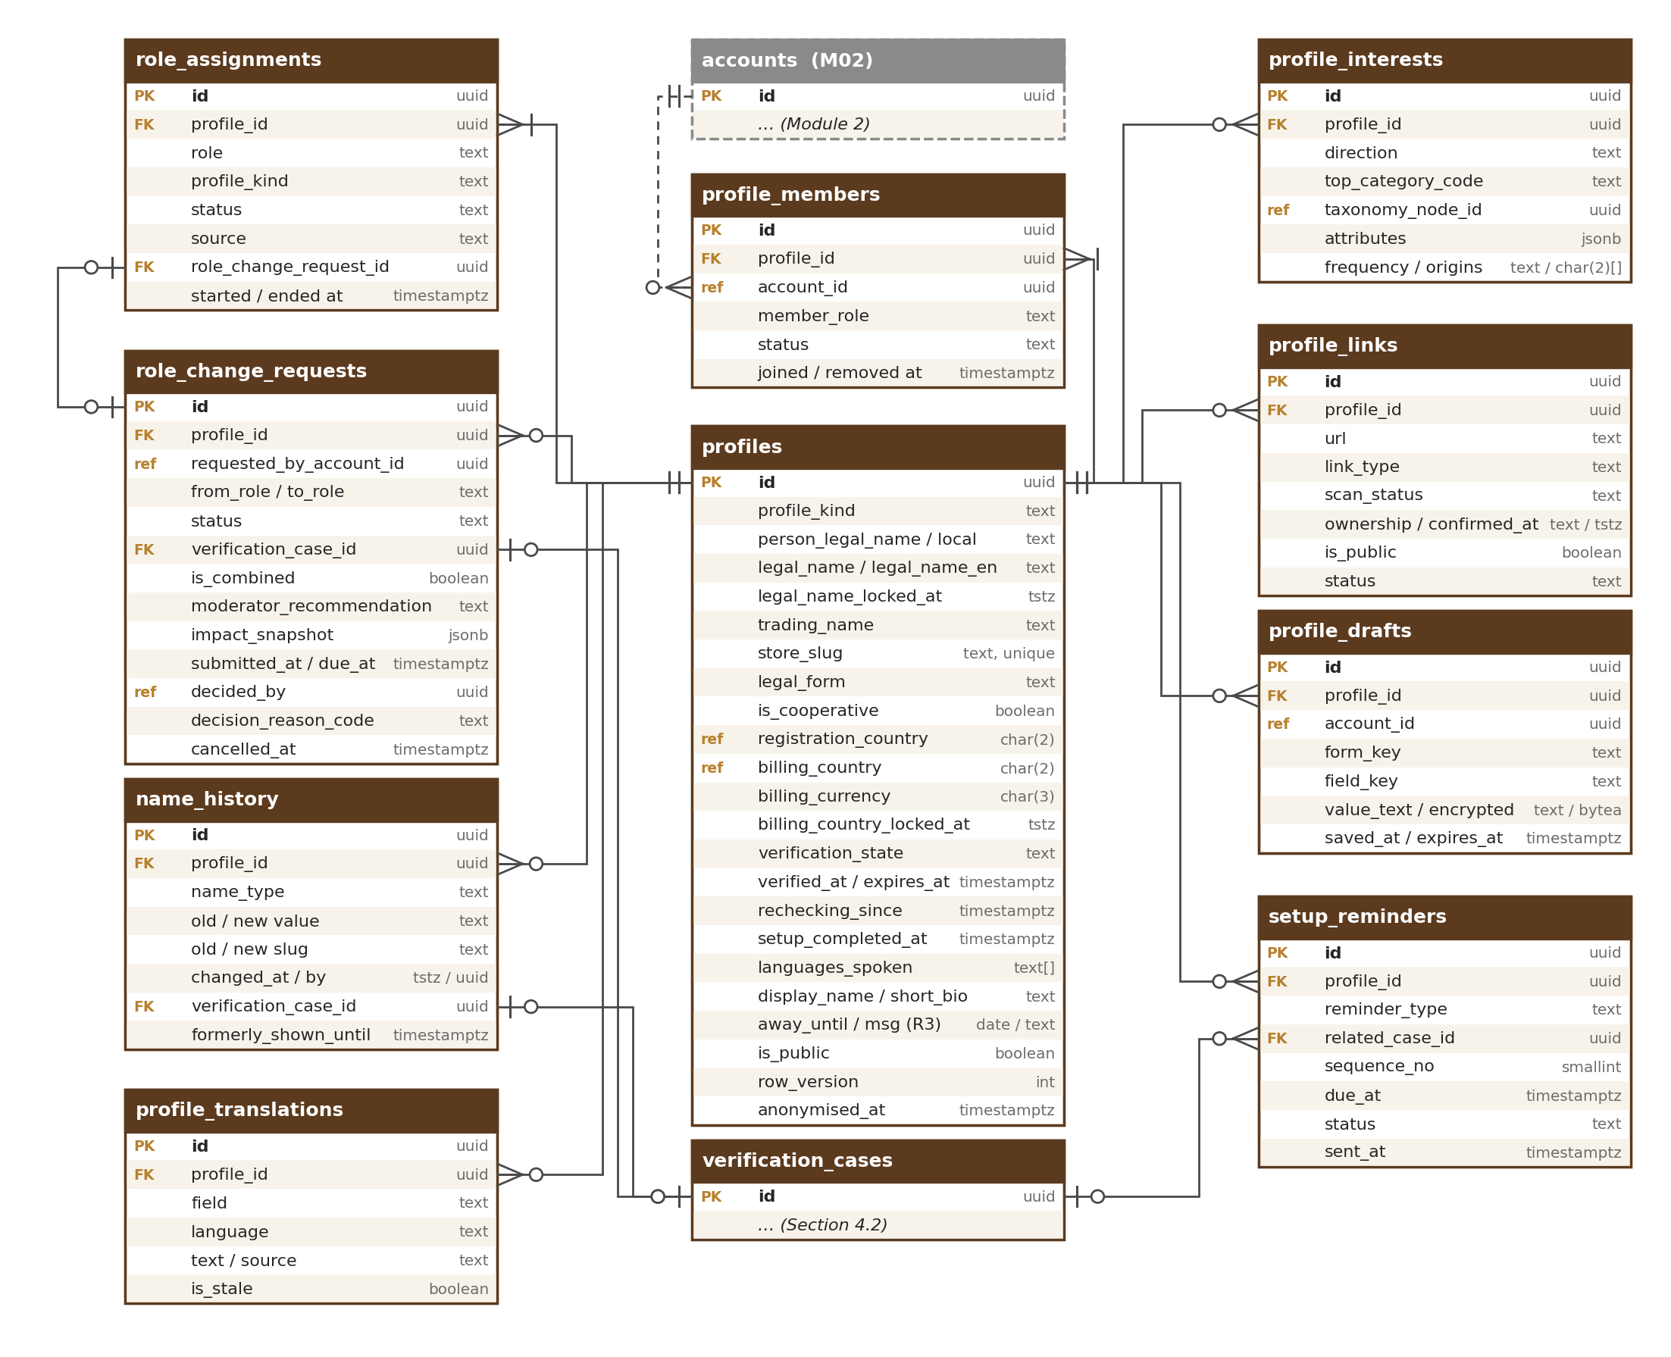
Figure 2 — Profiles, roles, names, extras, drafts and reminders

2.1 profiles
One row per marketplace profile (business or individual), created on account.created (M03-2 ROL-004). In V1 one account = one profile = one member (PRD-ROL-021). Holds names, legal form, billing country and the current verification state; the history of that state is in verification_cases.
Column | Type | Notes
id | uuid PK | The profile ID every module uses (listings, requirements, threads, subscriptions belong to the profile)
profile_kind | text | business, individual (check). Farmers and individual buyers are individual; all other roles and business buyers are business
person_legal_name / person_name_local | text / text | Individuals and farmers: name as on ID, and the local-script spelling (FRM-001); length ≤ 150 (check). The only stored copy of the name as on the ID; the M02 account keeps only a display name (PRF-015)
display_name | text | Public display name: chosen by a farmer (for example “Rahim, Hojai”); for other roles null and the trading name is used (PRF-015); length 2–60 (check)
legal_name / legal_name_en | text / text | Businesses: registered name stored as written (any script) and an optional English spelling (BUS-008, PRF-013)
legal_name_locked_at | timestamptz | Set at first approval; after it the legal name changes only through re-verification (PRF-012)
trading_name | text | Store name shown on the storefront; M01 store-name rules and reserved names (PRF-011); length 3–60 (check)
store_slug | text | UNIQUE; page address /store/{store_slug}, made by the M01 UrlService; the old slug redirects after a change (name_history)
trading_name_changed_at | timestamptz | Last store-name change; drives the once-per-90-days rule (PRF-011)
legal_form | text | proprietorship, partnership, llp, private_company, public_company, producer_company, cooperative_society, trust, society, huf, other (check) (BUS-012)
is_cooperative | boolean | “We are a Co-operative / FPO” chosen by a Company (ROL-007); the badge itself needs staff approval (TRS-004)
registration_country | char(2) (ref) | Country of registration chosen first in business details (BUS-001); null for individuals
billing_country / billing_currency | char(2) (ref) / char(3) | Approved registration country for businesses, account country for farmers and individuals (TRS-009); INR or USD
billing_country_locked_at | timestamptz | Set at approval; changes only through re-verification (TRS-009, TRS-010)
verification_state | text | not_started, pending, verified, rejected, resubmitted, expired, on_hold, revoked (check) (VER-001). Copy of the state of the profile’s current main case, kept in the same transaction
verification_state_changed_at | timestamptz
verified_at / verification_expires_at | timestamptz / timestamptz | First approval and the earliest expiry of a required document (VER-012); badges keep their own “as of” date
listings_grace_until | timestamptz | After expiry: live listings stay until this time (30 days, configurable), then are hidden (VER-013)
rechecking_since | timestamptz | Set while a re-verification case is open; the badge shows “re-checking” (VER-016)
setup_completed_at | timestamptz | First time all “Required to publish” items were done; buyers have no Required items, so for them it is set when the buyer profile is created. The setup card and the “Make your profile stronger” card are otherwise computed live (DSH-010, DSH-012, DSH-018)
setup_dismissed_items | text[] | Recommended item keys a buyer set to “Not now” (DSH-012); they move to the end of the “Make your profile stronger” card; empty by default
also_active_as | text[] | Private “also active as” roles (ROL-008); grants nothing
short_bio | text | Public short bio for cards and search (PRF-014); length ≤ 300 (check); contact details and banned claims refused by the service
description / original_language | text / text | Profile description (“About your business”) as written and its language (PRF-005, PRF-008); length ≤ 1,000 (check); contact details refused
year_established / business_size | smallint / text | Optional (BUS-013); size bands 1_5, 6_20, 21_100, over_100 (check)
languages_spoken | text[] | Language codes shown on the storefront (PRF-005)
logo_file_id / cover_file_id / photo_file_ids | uuid (ref) / uuid (ref) / uuid[] (ref) | Public photos through the M01 photo pipeline (M01 photo rules)
is_public | boolean | False when the account is not active, verification is revoked, the profile is individual (buyers) or the grace ended; the storefront then answers a neutral 404 (PRF-003, DAT-010). Kept by ProfileService from the two states — never set by a user switch
setup_reminders_off_at | timestamptz | User turned setup reminders off (NTF-001); expiry notices and decisions still go
adult_confirmed_at | timestamptz | Copy of the newest identity_checks.adult_confirmed_at (IDV-006); no date of birth is stored
away_until | date | Away mode, planned release: R3 (stays null until it is built). Away mode (PRF-018): “Away until {date}”, at most 60 days ahead (profile.away.max_days); null = not away; a past date counts as not away. Selling roles only (service rule); a field agent may set it for a delegated farmer
away_message | text | Away mode, planned release: R3. Optional message used in the M09 automatic reply; length ≤ 300 (check); contact details refused by the service
row_version / anonymised_at | int / timestamptz | Standard

Data level: Confidential (names of individuals, billing country, state); legal and trading names, display name, short bio, description, business size band, registration country, languages, photos and (from R3) away_until of verified sellers are Public once shown on the storefront; away_message (R3) is shown only in the automatic reply. Retention: kept while the account exists; on account.closed the profile is hidden at once and, after the M02 grace, anonymised: person names, description and photos cleared; legal name kept only where invoices or legal orders refer to it [TBC: C10]. Indexes: UNIQUE (store_slug); UNIQUE (lower(trading_name)) where not anonymised; (verification_state, verification_expires_at); partial (listings_grace_until) where verification_state = expired; (registration_country); (is_public).

2.2 profile_members
Accounts that act for a profile, with a member role (Master Database Design D1). V1: exactly one active member, the owner.
Column | Type | Notes
id | uuid PK
profile_id | uuid FK → profiles
account_id | uuid (ref) | M02 account
member_role | text | owner, admin, sales, viewer (check); V1 only owner
status | text | active, removed (check)
joined_at / removed_at | timestamptz / timestamptz

Data level: Internal. Retention: kept while the profile exists; removed rows kept 12 months. Indexes: UNIQUE partial (account_id) where status = active (one profile per account, D15); UNIQUE partial (profile_id) where status = active and member_role = owner; (profile_id).

2.3 role_assignments
Marketplace role of a profile and its history (ROL-001). One active role per profile in V1; every role can also buy.
Column | Type | Notes
id | uuid PK
profile_id | uuid FK → profiles
role | text | buyer, seller, company, nursery, inoculation_provider, farmer (check)
profile_kind | text | Copy of profiles.profile_kind so the database can check the pair: farmer → individual; seller, company, nursery, inoculation_provider → business; buyer → either (check constraint ck_role_assignments_role_kind)
status | text | active, ended (check)
source | text | signup, role_correction, role_change, buyer_upgrade, staff (check)
role_change_request_id | uuid FK → role_change_requests | When the role came from an approved request
started_at / ended_at | timestamptz / timestamptz

Data level: Public (the role is shown on the storefront). Retention: life of the profile (history for audits and appeals). Indexes: UNIQUE partial (profile_id) where status = active; (role, status).

2.4 role_change_requests
Requests to change role, decided by Admin within 48 business hours (ROL-009 to ROL-017). The new role’s documents are a verification case of type role_change; a buyer → selling role request is one combined case of type role_change_combined (ROL-017).
Column | Type | Notes
id | uuid PK
profile_id | uuid FK → profiles
requested_by_account_id | uuid (ref) | M02 account
from_role / to_role | text / text | Same values as role_assignments.role; the path is checked by RoleService against the setting profile.role_change.paths (upgrades only, ROL-010)
is_combined | boolean | Buyer → selling role: role and full verification decided together in one case (ROL-017)
moderator_recommendation / recommended_by / recommended_at | text / uuid (ref) / timestamptz | Combined case only: approve, reject (check) recorded by a Moderator after reviewing documents and identity; the Admin decision follows (ROL-017)
status | text | requested, documents_needed, in_review, approved, rejected, cancelled (check)
is_self_service | boolean | Buyer Individual → Business (ROL-015): approved at once, no Admin decision
reason_text | text | User’s optional note
verification_case_id | uuid FK → verification_cases | Case holding the new role’s documents
impact_snapshot | jsonb | What the screen showed before submit: listings that go back to draft (count and IDs), badges that end, billing country that will apply (ROL-009) — a snapshot, never read for decisions
step_up_at | timestamptz | Time of the M02 step-up before submit
submitted_at / due_at | timestamptz / timestamptz | due_at from the M01 business-hours calculator (VER-007)
decided_by / decided_at | uuid (ref) / timestamptz | M02 staff user
decision_reason_code / decision_message | text / text | Reason shown to the user when rejected (ROL-016)
cancelled_at | timestamptz | User cancelled; current role untouched, documents kept (ROL-013)
listings_moved_to_draft | int | Number reported by M05 after approval
row_version | int

Data level: Confidential. Retention: 3 years after the decision [TBC: C10], then deleted; the audit log keeps the decision. Indexes: UNIQUE partial (profile_id) where status in (requested, documents_needed, in_review) — one open request (ROL-011); (profile_id, created_at) for the 3-per-year limit; (status, due_at) for the M15 queue.

2.5 name_history
Store (trading) and legal name changes (PRF-011, PRF-012). Append-only.
Column | Type | Notes
id | uuid PK
profile_id | uuid FK → profiles
name_type | text | trading, legal (check)
old_value / new_value | text / text
old_slug / new_slug | text / text | Store address before and after; M01 keeps the redirect (profile.renamed)
changed_at / changed_by | timestamptz / uuid | Account or staff user
source | text | user, reverification, staff (check)
verification_case_id | uuid FK → verification_cases | Legal name changes: the re-verification case
formerly_shown_until | timestamptz | changed_at + 90 days (configurable): the storefront shows “Formerly {old name}” until then (trading names only)

Data level: Public for trading names shown as “Formerly”; Confidential otherwise. Retention: life of the profile (buyers and moderators need past names to spot name-change scams). Indexes: (profile_id, changed_at desc); (lower(old_value)) for Support searches.

2.6 profile_translations
Translated profile texts (Master Database Design D6; PRF-008). The user’s own text in profiles is the original.
Column | Type | Notes
id | uuid PK
profile_id | uuid FK → profiles
field | text | description (check; more fields later)
language | text | Language code
text | text
source | text | user, machine, human (check); machine translations come through the M01 AI gateway and are labelled
is_stale | boolean | Set when the original changes; stale machine rows are re-made, stale user rows flagged to the user
translated_at | timestamptz

Data level: Public. Retention: with the profile. Index: UNIQUE (profile_id, field, language).

3. Business Details and Locations
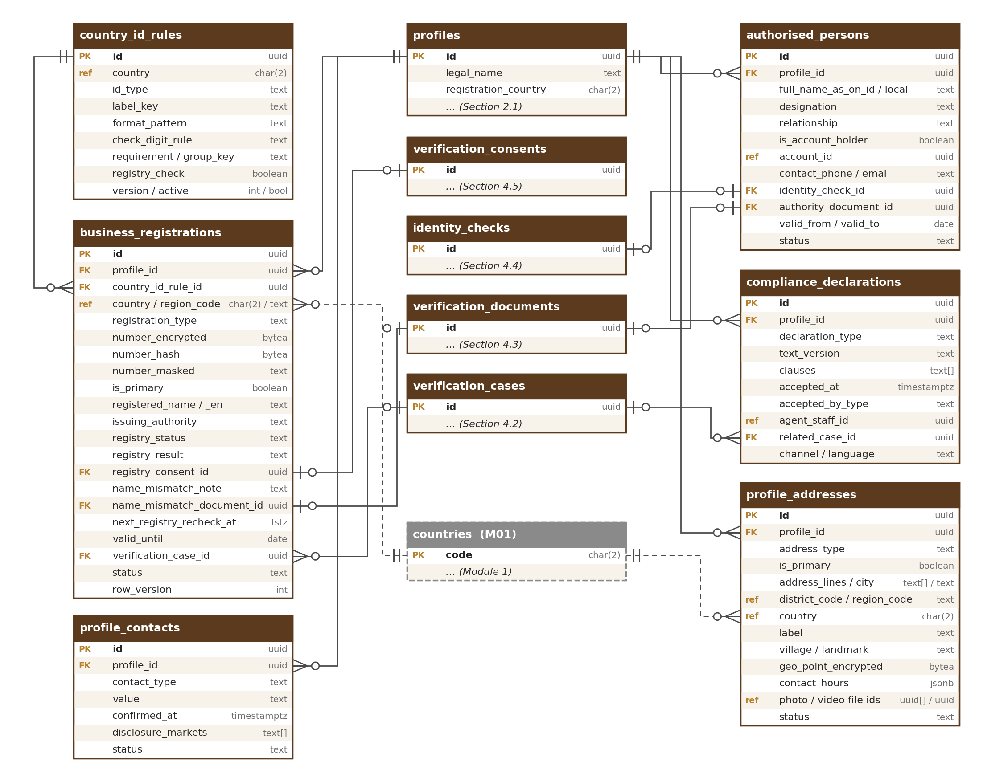
Figure 3 — Business details, registrations, authorised person, declarations and locations

3.1 country_id_rules
Per-country business ID fields: label, format, check digit, requirement group and whether the registry check is available (M03-2 Section 4.1). Reference data changed in the business ID rules editor (M03-6 Section 16.8) and published through M01 ConfigService with a second approver (M03-2 DAT-012); nothing country-specific is written into the app.
Column | Type | Notes
id | uuid PK
country | char(2) (ref) | Country code, or ZZ for the fallback set used by unmapped countries
id_type | text | gstin, pan, cin, llpin, udyam, udyam_assist, coop_registration, iec, trade_licence, trade_licence_authority, trn, cr, vat, registration_no, registering_authority, tax_no (check); iec is optional and never in the main_registration group (BUS-020)
label_key / help_key / error_key | text / text / text | M01 translation keys for label, help and the configured error message (BUS-003)
format_pattern | text | Regular expression checked in the browser and again on the server
check_digit_rule | text | gstin, pan, none (check)
example_value | text | Shown as placeholder
requirement / group_key | text / text | required, one_of_group, optional (check); group_key names the group (India: main_registration = GSTIN, CIN / LLPIN, Udyam incl. Udyam Assist)
applies_to_forms | text[] | Legal forms the field applies to (empty = all)
registry_check | boolean | Registry auto-check available for this type (India GSTIN, PAN, CIN / LLPIN, Udyam in R1)
shown_publicly | boolean | A verified registration of this type is shown on the storefront, masked with its status (PRF-001). India: true for GSTIN, CIN / LLPIN, Udyam (incl. Udyam Assist) and IEC; always false for PAN
mask_rule | text | How the masked number is shown: last4 (default), first2_last4 (check)
display_order | smallint
version / active / effective_from | int / boolean / timestamptz | Versioned; retired, never deleted
row_version | int

Data level: Internal. Retention: reference data, retired never deleted. Rule: a country uses either its own active rules or the fallback set, never both; publishing a country’s own rules retires the fallback marker for that country in the same transaction (constraint trigger refuses both). Seed data (R1 launch gate, DOC-003): India (full, registry check), United Arab Emirates and Saudi Arabia (manual review), fallback ZZ; R2 adds Vietnam, Indonesia, Malaysia, Thailand, Cambodia, Laos, Sri Lanka and Papua New Guinea. Indexes: UNIQUE (country, id_type, version); (country, active).

3.2 business_registrations
Registration and tax numbers of a business with the registry-check result and the monthly status check (BUS-004 to BUS-007, BUS-016, BUS-018). A business may have several (for example one GSTIN per state); one is primary.
Column | Type | Notes
id | uuid PK
profile_id | uuid FK → profiles
country_id_rule_id | uuid FK → country_id_rules | Rule version the number was checked against
country / region_code | char(2) (ref) / text | Issuing country; state for GSTIN and nursery licences (ISO 3166-2)
registration_type | text | Same values as country_id_rules.id_type (includes iec, BUS-020)
issuing_authority | text | Body that issued it where a country has several, for example a UAE emirate department or free zone (from the country_id_rules list) or the registering authority typed for the fallback (BUS-021)
number_encrypted | bytea | Field-level encrypted number
number_hash | bytea | Keyed hash (HMAC) of the normalised number: duplicate check and M02 ban-evasion signal (BUS-016)
number_masked | text | For example 18AAB•••••••1ZM; the storefront shows the type and this masked form (PRF-001)
is_primary | boolean
registered_name / registered_name_en | text / text | Name returned by the registry or typed for manual review
registered_legal_form | text | Constitution returned by the registry
registration_date | date
registered_address | jsonb | Address returned by the registry (supplier payload, country layout); the editable copy is the registered row in profile_addresses
registry_status | text | active, suspended, cancelled, struck_off, under_liquidation, dormant, unknown (check) (BUS-007)
registry_result | text | matched, not_found, pending_retry, supplier_down, declined, manual (check)
registry_consent_id | uuid FK → verification_consents | Consent to the registry look-up (DAT-004)
registry_checked_at / registry_supplier_ref | timestamptz / text
registry_attempts / next_retry_at | smallint / timestamptz | Retries every 30 minutes for 24 hours when the supplier is down, then manual review (BUS-005)
name_match_result / name_match_score | text / numeric(5,2) | match, close, mismatch (check) — a warning for the reviewer, never a refusal (BUS-009)
name_mismatch_note | text | Private explanation from the user, ≤ 500 characters; shown only to reviewers (BUS-022)
name_mismatch_document_id | uuid FK → verification_documents | Optional explaining document (gazette notice, marriage certificate) (BUS-022)
valid_until | date | Only for registrations that really expire (trade licences, nursery licences, CR where shown)
next_registry_recheck_at / last_status_change_at | timestamptz / timestamptz | Monthly registry re-check of registrations without an expiry date (BUS-018)
duplicate_flagged_at | timestamptz | Same number on another profile: business-claim review (BUS-016)
verification_case_id | uuid FK → verification_cases | Case in which it was submitted
status | text | draft, submitted, verified, replaced, removed (check)
row_version | int

Data level: Restricted (number_encrypted, number_hash); Confidential (names, address, registry results, name_mismatch_note — reviewers only); Public (type, number_masked, status and issuing authority of each verified registration whose type is shown publicly — country_id_rules.shown_publicly; India: GSTIN, CIN / LLPIN, Udyam and IEC). PAN is never public, not even masked. Retention: verified rows kept while the account is active, then per counsel [TBC: C10]; draft and removed rows 90 days. Indexes: (number_hash) — not unique, duplicates are flagged not blocked; UNIQUE partial (profile_id) where is_primary and status in (submitted, verified); partial (next_registry_recheck_at) where status = verified; partial (next_retry_at) where registry_result = pending_retry; (profile_id, status); (name_mismatch_document_id).

3.3 authorised_persons
The person who acts for the business (BUS-014); may differ from the account holder. Changing the current person starts re-verification (VER-016).
Column | Type | Notes
id | uuid PK
profile_id | uuid FK → profiles
full_name_as_on_id / name_local | text / text
designation / designation_text | text / text | director, partner, proprietor, authorised_signatory, other (check) + free text
relationship | text | self, employee, family_member, partner, director, agent, other (check) — relationship to this sign-in
is_account_holder | boolean | “I am the authorised person”
account_id | uuid (ref) | M02 account when it is the account holder
contact_phone / contact_email | text / text | Only when they are someone else: for the remote identity link (IDV-012)
identity_check_id | uuid FK → identity_checks | Their current passed check
authority_document_id | uuid FK → verification_documents | Proof of authority: always for Company, otherwise only when names do not match (BUS-010)
valid_from / valid_to | date / date
status | text | current, replaced (check)
row_version / anonymised_at | int / timestamptz

Data level: Confidential. Retention: current row while the account is active; replaced rows 3 years [TBC: C10]. Indexes: UNIQUE partial (profile_id) where status = current; (identity_check_id).

3.4 compliance_declarations
Signed declarations, versioned, append-only (BUS-015, FRM-006, FRM-017, ENH-002). The compliance declaration has the agarwood clauses; the same table stores field-agent and FPO confirmation declarations and the “no one owns 25 % or more” declaration.
Column | Type | Notes
id | uuid PK
profile_id | uuid FK → profiles | Profile the declaration is about (the farmer for agent and FPO confirmations)
declaration_type | text | compliance, agent_confirmation, fpo_confirmation, no_major_owner (check). family_land: Removed (25 Sep 2026): land papers belong to the listing (Module 5/6)
text_version / language | text / text | M17 text version and language shown or played
clauses | text[] | compliance: legal_origin, no_wild_sourced, cites_for_exports, no_promised_returns
accepted_at | timestamptz
accepted_by_type | text | user, field_agent, fpo (check)
account_id / agent_staff_id | uuid (ref) / uuid (ref) | Who declared (M02 account or staff user)
related_case_id | uuid FK → verification_cases
channel / ip | text / inet | web, app, field_agent; IP cleared at anonymisation
superseded_at | timestamptz | When a newer version was accepted

Data level: Confidential. Shown publicly only as “Compliance declaration on file (self-declared)” (PRF-001). Retention: life of the profile + [TBC: C10] as proof. Indexes: (profile_id, declaration_type, accepted_at desc); (agent_staff_id).

3.5 profile_addresses
Registered address and business locations with their public details; the private home address of farmers (village) and buyers (city) (LOC-001 to LOC-010).
Column | Type | Notes
id | uuid PK
profile_id | uuid FK → profiles
address_type | text | registered, office, plantation, nursery, distillery, factory, warehouse, shop, home, other (check); home = farmer’s home (village) or buyer’s city (only city and country filled) (LOC-010)
is_primary | boolean | Pre-fills the region on new listings and requirements (LOC-006)
label | text | Optional site label, ≤ 60 characters; public with the site type (LOC-007)
address_lines / city | text[] / text | Country layout (M01)
district_code / region_code / postal_code | text (ref) / text / text | M01 district list (India LGD) and ISO 3166-2
country | char(2) (ref) | A location’s country changes nothing about documents or billing (LOC-005)
village | text | Village of a farmer’s home address; private (LOC-010)
landmark | text | For villages without street or PIN
geo_point_encrypted | bytea | Optional map pin, field-level encrypted
contact_hours | jsonb | Optional: days and time ranges with the time zone, for example {days: [mon…sat], from: 09:00, to: 18:00, tz}; public as “Usually available {days} {hours}” (LOC-008); farmers may set working days and hours on their home row, public in the same way (never the village)
photo_file_ids / video_file_id | uuid[] (ref) / uuid (ref) | Up to 2 site photos (check) and 1 short video ≤ 3 MB, M01 files; public only after the M01 safety review (LOC-009)
source | text | registry, user, field_agent (check)
reviewer_note | text | Why the registered address differs from the registry (BUS-008)
public_display_level | text | district, state (check); street address is never public (LOC-004)
status | text | active, removed (check)
row_version / anonymised_at | int / timestamptz

Data level: Confidential (street address, village, home rows apart from a farmer’s contact hours); Restricted (geo_point_encrypted); Public (city or district, state and country, type, label, contact hours and approved photos and video of business locations; the optional contact hours of a farmer’s home row). Retention: active rows while the profile exists; removed rows 12 months. Indexes: UNIQUE partial (profile_id) where is_primary and status = active; (profile_id, status); (district_code). The rule “a selling business keeps at least one active location” is checked by LocationService (LOC-001).

3.6 profile_contacts
Private business phone and email (BUS-013, PRF-002). Never shown publicly; used by OudhTrade and, if counsel requires, for per-market disclosure later.
Column | Type | Notes
id | uuid PK
profile_id | uuid FK → profiles
contact_type | text | business_phone, business_email (check)
value | text | E.164 phone or lower-case email
confirmed_at | timestamptz | Confirmed by code through M02 Otp (optional in R1)
disclosure_markets | text[] | Empty in R1: room for EU DSA and US INFORM disclosure switches if counsel requires them (C14, C17); not built now
status | text | active, replaced (check)
row_version / anonymised_at | int / timestamptz

Data level: Confidential. Retention: while the account is active; replaced rows 12 months. Indexes: UNIQUE partial (profile_id, contact_type) where status = active.

4. Verification, Identity Checks and Badges
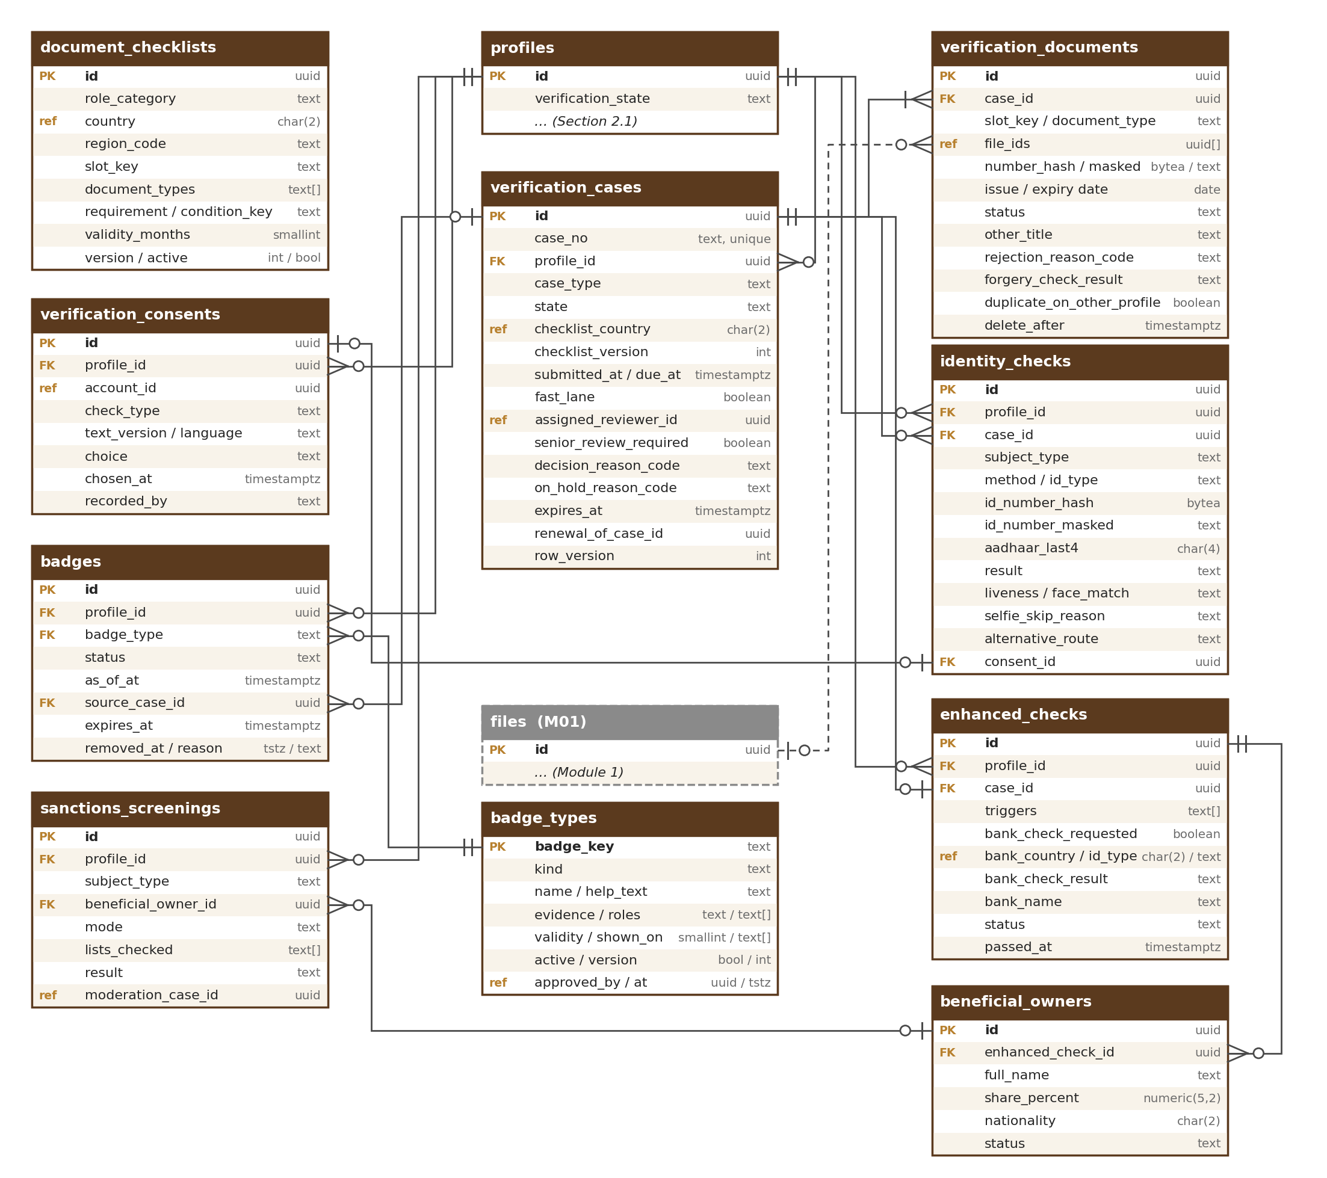
Figure 4 — Verification cases, documents, identity checks, consents, badges and enhanced check

4.1 document_checklists
Documents needed per role category and country, with validity rules (DOC-001 to DOC-006). It fills the Document type dropdown and the “You need” list of the Documents step (DOC-029). Reference data changed in the document checklists editor (M03-6 Section 16.7) and published through M01 with a second approver (M03-2 DAT-012); a country list may only add to the role’s basic set. New types found through frequent “Other document” names are added here (DOC-028).
Column | Type | Notes
id | uuid PK
role_category | text | seller, company, cooperative, nursery, inoculation_provider, farmer, buyer_business, buyer_individual, sole_trader_no_registration, lab (check)
country | char(2) (ref) | Null = the role’s basic set (fallback, manual review)
region_code | text | State rule (nursery licence where the state requires it, DOC-005)
slot_key | text | identity, business_registration, proof_of_authority, nursery_licence, address_proof, tax_id, lab_accreditation, cooperative_registration, badge_evidence, other (check); every dropdown ends with “Other document” (slot other, DOC-027). land_proof: Removed (25 Sep 2026): land papers belong to the listing (Module 5/6)
document_types | text[] | Document types shown in the dropdown for the slot (for example gst_certificate, udyam_certificate, trade_licence, nursery_licence, board_resolution); a required slot appears on the “You need” list
requirement / condition_key | text / text | required, conditional, optional (check); conditions: names_mismatch, state_requires, is_cooperative. land_offer: Removed (25 Sep 2026): land papers belong to the listing (Module 5/6)
validity_months / expiry_from_document | smallint / boolean | Default validity per type (business 24) or the document’s own date (DOC-004); registrations without expiry rely on the monthly registry check
max_files / accepted_formats / max_size_mb | smallint / text[] / smallint | 10 pages; PDF, JPG, PNG, HEIC/HEIF or WEBP; 10 MB (DOC-007 to DOC-010)
retention_class | text | Retention policy name registered with M01 (DOC-006)
sample_file_id / help_key | uuid (ref) / text | Sample image and help text shown before the picker
display_order | smallint
version / active | int / boolean
row_version | int

Data level: Internal. Retention: reference data, retired never deleted; cases keep the checklist version they used. Seed data (launch gate): India, UAE and Saudi Arabia for all role categories; basic sets for the fallback. Indexes: UNIQUE (role_category, coalesce(country, 'ZZ'), coalesce(region_code, ''), slot_key, version); (active).

4.2 verification_cases
Each verification request and its decision (VER-001 to VER-018, DOC-018 to DOC-025). Types: business, farmer (route A: ID check; route B: field agent or FPO), Verified buyer, business buyer, enhanced check, re-verification, renewal, role change, combined buyer → selling role case, lab accreditation, Co-operative / FPO badge, staff-awarded badge. A case is created as a draft when setup starts, so identity checks and documents always belong to a case.
Column | Type | Notes
id | uuid PK
case_no | text | UNIQUE public number, for example C-11045 (Master Database Design 4.2)
profile_id | uuid FK → profiles
case_type | text | business, farmer_route_a, farmer_route_b, verified_buyer, business_buyer, enhanced, reverification, renewal, role_change, role_change_combined, lab_accreditation, cooperative_badge, staff_badge (check); role_change_combined = buyer → selling role, the full verification and the role decided together (ROL-017); staff_badge = application for a staff-awarded badge (TRS-016)
state | text | draft, pending, rejected, resubmitted, verified, on_hold, revoked, withdrawn, closed (check); the profile’s verification_state follows its main case
role_at_submission | text
checklist_country / checklist_version | char(2) (ref) / int | Checklist used; is_fallback_checklist when none existed (DOC-002)
is_fallback_checklist | boolean | Manual review with a longer ETA shown
submitted_at / due_at | timestamptz / timestamptz | due_at = 48 business hours from the M01 calculator (VER-007)
paused_at / paused_seconds | timestamptz / int | ETA clock paused while a reviewer question waits (VER-006)
fast_lane | boolean | India, registry active, names match, identity passed or skipped, no flags (DOC-023)
escalated_at / eta_reissued_at | timestamptz / timestamptz | At 80 % of the target; new dated ETA after a miss (VER-009)
assigned_reviewer_id | uuid (ref) | M02 staff user
reviewer_languages | text[] | Languages needed to read the documents (routing, DOC-020)
senior_review_required | boolean | 3 rejections of the same document in 90 days (VER-010)
question_text / question_asked_at | text / timestamptz | “We have a question” (VER-006)
user_reply / replied_at | text / timestamptz
decided_by / decided_at | uuid (ref) / timestamptz
decision_reason_code / message_to_user | text / text | Reason list in M03-6 Section 16.2
internal_note | text | Never shown to the user
on_hold_reason_code | text | registry_change, sanctions_match, list_match, country_not_mapped, duplicate_document (check); never shown to the user
withdrawn_at | timestamptz | “Withdraw” to edit (DOC-015)
expires_at / expiry_basis | timestamptz / text | document_date, type_default, registry_monthly (check)
reminder_60_at / reminder_30_at / reminder_7_at | timestamptz | Sent expiry reminders (VER-012)
renewal_of_case_id | uuid FK → verification_cases | Renewal keeps the badge while decided (VER-014)
reverification_reason | text | authorised_person, legal_name, registration_number, registration_country, owners (check) (VER-016)
alternative_route | text | video_call, field_agent (check) — longer ETA
supplier_share_consent_id | uuid FK → verification_consents | Consent before documents go to the verification supplier
auto_approved / audit_sampled | boolean / boolean | Approved without a reviewer while the automatic-approval switch was on (fully matched India fast lane only); picked for the random audit (default 10 %) (DOC-023)
audit_outcome / audited_by / audited_at | text / uuid (ref) / timestamptz | passed, problem_found (check); the Moderator who audited it; null until audited
row_version | int

Data level: Confidential (Restricted content lives in verification_documents and identity_checks). Retention: life of the profile + [TBC: C10] (decisions are evidence for appeals and legal orders); internal notes kept with the case. Indexes: UNIQUE (case_no); (profile_id, created_at desc); (state, fast_lane, due_at) for the queue; partial (due_at) where state in (pending, resubmitted); partial (expires_at) where state = verified; (assigned_reviewer_id, state).

4.3 verification_documents
Documents submitted in a case (DOC-007 to DOC-022, DOC-029). One row per added document; the pages are private M01 files.
Column | Type | Notes
id | uuid PK
case_id | uuid FK → verification_cases
profile_id | uuid FK → profiles | For fast per-profile queries
slot_key / document_type | text / text | From document_checklists; document_type chosen in the Document type dropdown (DOC-026, DOC-029)
other_title | text | Only for slot_key other: the user’s short title, ≤ 80 characters (check); counted in the checklist-growth report (DOC-027, DOC-028)
file_ids | uuid[] (ref) | M01 private files, up to 10 pages (DOC-010); HEIC/HEIF and WEBP converted by M01
page_count | smallint
issuing_country / issuing_region | char(2) (ref) / text
number_encrypted / number_hash / number_masked | bytea / bytea / text | Document number when the type has one; hash to M02 ban-evasion signals
name_on_document | text | For name matching
issue_date / expiry_date | date / date | Read or asked at upload (DOC-012)
status | text | uploaded, submitted, accepted, rejected, replaced, withdrawn, deleted (check)
rejection_reason_code / rejection_message | text / text | Plain guidance with what to send (DOC-022)
rejection_seq | smallint | Nth rejection of this slot in 90 days (VER-010)
forgery_check_result | text | clean, warning, unavailable (check) — a warning to the reviewer only (DOC-019)
quality_warning | text | blur, glare, cut_off (check) — from the phone-camera check
type_check_result | text | matches, looks_different, not_checked (check) (DOC-013)
duplicate_on_other_profile | boolean | Flagged, never blocked (DOC-019)
is_digitally_signed / signature_valid | boolean / boolean | DigiLocker and other signed PDFs (DOC-016)
converted_from_format | text | heic, heif, webp
document_language | text | Detected or chosen language
translation_file_id | uuid (ref) | Reviewer translation (M01 private file, numbers removed before sending — DOC-020); deleted with the document
decided_by / decided_at | uuid (ref) / timestamptz
superseded_by_id | uuid FK → verification_documents | Replacement document
delete_after / deleted_at | timestamptz / timestamptz | Rejected or replaced documents, and bank proof files of the enhanced check whatever the result (ENH-003): decided_at + 90 days (profile.documents.delete_after_days), unless a legal hold or fraud case applies (DAT-007)
row_version | int

Data level: Restricted (files, numbers, name on document, translation). Opened by staff only in the watermarked viewer, every view in the M01 audit log (DOC-021). Retention: accepted documents while the account is active, then per counsel [TBC: C10] (except bank proof files of the enhanced check, deleted 90 days after the decision whatever the result, ENH-003); rejected and replaced ones deleted 90 days after the decision (row kept without files and numbers as a record). Indexes: (case_id); (profile_id, slot_key, status); (number_hash); partial (delete_after) where deleted_at is null; partial (issuing_country, lower(other_title)) where slot_key = other — for the checklist-growth report (DOC-028).

4.4 identity_checks
Identity check of a person: route, ID, result and the live-selfie result (IDV-001 to IDV-015, FRM-006). Also records in-person checks by a field agent and the alternative routes.
Column | Type | Notes
id | uuid PK
profile_id | uuid FK → profiles
case_id | uuid FK → verification_cases
subject_type | text | account_holder, authorised_person, farmer, buyer, beneficial_owner (check)
authorised_person_id | uuid FK → authorised_persons | When the subject is the authorised person
method | text | digilocker, upload, aadhaar_otp, field_agent_in_person, video_call (check)
id_type | text | pan, driving_licence, voter_id, passport, emirates_id, saudi_national_id, iqama, national_id, aadhaar (check); aadhaar only with method aadhaar_otp, never with method upload (check); per-country list in settings
id_issuing_country | char(2) (ref)
name_on_id | text | For name matching
id_number_hash / id_number_masked | bytea / text | Never set when id_type = aadhaar (check ck_identity_checks_no_aadhaar_number)
aadhaar_last4 | char(4) | Only when id_type = aadhaar (check); never the full number, XML or photo (IDV-002)
provider / provider_reference | text / text | DigiLocker, UIDAI e-KYC provider, selfie supplier
digilocker_mobile_matches | boolean | DigiLocker ID’s linked mobile equals the account’s confirmed phone (IDV-008)
id_file_ids | uuid[] (ref) | Uploaded ID images (M01 private files)
id_expiry_date | date | Expired IDs refused (IDV-005)
result / result_reason_code | text / text | pending, passed, failed, manual_review (check)
attempt_count | smallint
adult_confirmed_at | timestamptz | ID shows 18 or over; no date of birth stored (IDV-006)
selfie_required / selfie_skip_reason | boolean / text | aadhaar_face_match, digilocker_mobile_match (check)
liveness_result / face_match_result | text / text | pass, fail, not_done / match, no_match, manual_match, not_done (check)
face_match_score | numeric(5,2) | Biometric-derived
selfie_attempts / selfie_supplier_ref | smallint / text | 3 in a row, 5 a day (IDV-010)
selfie_deleted_at | timestamptz | Confirmed deletion of the selfie at the supplier and in M01 (DAT-007)
alternative_route | text | remote_link, video_call, field_agent (check) (IDV-012, IDV-013)
remote_link_token_hash / remote_link_expires_at / remote_link_status | bytea / timestamptz / text | 7-day secure link to the authorised person’s own phone; sent, opened, done, expired, cancelled
video_call_staff_id / agent_staff_id | uuid (ref) / uuid (ref) | Staff member or field agent who checked in person
video_call_reason / video_call_gender | text / text | face_covering, disability, biometric_refused, no_camera, selfie_failed, other (check) / woman, man, no_preference (check) — the user’s request for a same-gender call (IDV-013)
video_call_status / video_call_at / video_call_missed | text / timestamptz / smallint | requested, booked, done, missed, cancelled (check); booked time; missed calls (after 2 a field-agent check is suggested)
seen_at / seen_place_encrypted | timestamptz / bytea | Route B: place and time the agent saw the ID (FRM-006)
nationality | char(2) | Enhanced check only, to clear name matches (ENH-007)
reviewer_override_by / reviewer_override_at | uuid (ref) / timestamptz | Manual face comparison (IDV-011)
consent_id | uuid FK → verification_consents
captured_offline / client_idempotency_key | boolean / text | Route B forms saved offline on the agent’s device (FRM-012); the key is UNIQUE
checked_at / row_version / anonymised_at | timestamptz / int / timestamptz

Data level: Restricted (name_on_id, number hash and mask, aadhaar_last4, face-match score, ID images, place); Confidential (method, result). Retention: the passed check while the account is active, then per counsel [TBC: C10]; failed checks 90 days; ID images deleted with the decision class of their document; selfies never kept. Indexes: (profile_id, subject_type, checked_at desc); (case_id); (id_number_hash); UNIQUE (client_idempotency_key) where not null; partial (remote_link_expires_at) where remote_link_status in (sent, opened).

4.5 verification_consents
Consent to each third-party check, versioned, append-only (DAT-004, DAT-005): registry look-up, DigiLocker, Aadhaar OTP e-KYC, selfie / face match (biometric), bank account check, sending documents to the document forgery check supplier.
Column | Type | Notes
id | uuid PK
profile_id | uuid FK → profiles
account_id | uuid (ref) | Who consented: the user, or the authorised person through the remote link
subject_type | text | account_holder, authorised_person, farmer, buyer (check)
check_type | text | registry_lookup, digilocker, aadhaar_ekyc, selfie_match, bank_check, supplier_document_share (check)
text_version / text_language | text / text | M17 text; en, hi, as, bn for farmers
audio_played | boolean | Farmer consent read aloud
choice | text | given, declined, withdrawn (check); declining offers the manual or alternative route
chosen_at | timestamptz
channel / recorded_by | text / text | web, app, field_agent / user, field_agent
agent_staff_id | uuid (ref) | Field agent who recorded it
ip | inet | Cleared at anonymisation

Data level: Confidential. Retention: life of the profile + [TBC: C10] as proof of consent. Index: (profile_id, check_type, chosen_at desc).

4.6 badges
Badges given to a profile, with their “as of” date (TRS-001 to TRS-005, TRS-012, TRS-013, TRS-016). The type comes from badge_types (Section 4.7): the 12 automatic badges — Business verified, Verified farmer, Verified buyer, Co-operative / FPO, Women-led enterprise (self-declared), Founding Seller, Enhanced check passed, Farm visited, Accredited lab, GST registered, OudhTrade Partner (R2), Trusted (R2) — and staff-awarded badges created by Admin. Listing badges such as “Export permitted” belong to M05 / M06.
Column | Type | Notes
id | uuid PK
profile_id | uuid FK → profiles
badge_type | text FK → badge_types | badge_types.badge_key; automatic keys business_verified, verified_farmer, verified_buyer, cooperative_fpo, women_led, founding_seller, enhanced_check_passed, farm_visited, accredited_lab, oudhtrade_partner, gst_registered, trusted; staff-awarded keys as created by Admin
status | text | active, rechecking, removed (check)
as_of_at | timestamptz | Approval, visit, check or declaration date shown publicly
source_case_id | uuid FK → verification_cases | Case that earned it (staff-awarded badges: the staff_badge case; null for Founding Seller and Women-led; Founding Seller is marked automatically by M11 from profile.verified, PRD-MON-004)
source_ref | uuid | farm_visits, lab_accreditations, partners or business_registrations (gst_registered) row, the M11 Founding Seller mark (automatic: the first {n} sellers verified within {months} after R1, PRD-MON-004) or the M10 trust record (trusted) (typed by badge_type)
is_self_declared / evidence_file_id | boolean / uuid (ref) | Women-led enterprise (TRS-003)
expires_at | timestamptz | Document or visit expiry; staff-awarded badges: as_of_at + badge_types.validity_months
removed_at / removal_reason_code / removed_by | timestamptz / text / uuid
row_version | int

Data level: Public (type and “as of” date of active badges). Retention: removed badges kept 3 years for audits. Indexes: UNIQUE partial (profile_id, badge_type) where status in (active, rechecking); (badge_type, status); (expires_at).

4.7 badge_types
Reference list of badge types (TRS-016, PRD-ROL-046). Automatic types keep their rules in code; only help text, translations and time settings change without code. Staff-awarded types are created by Admin without code and go live after a second approver. Changed in the badge types editor (M03-6 Section 16.12) through the approved publish step (M03-2 DAT-012).
Column | Type | Notes
badge_key | text PK | Stable key, lower case (for example business_verified); badges.badge_type points here
kind | text | automatic, staff_awarded (check); a new automatic type needs a code release
name / help_text | text / text | Shown name and the “What we checked” help text (English original; translations in the M01 translation store). Names of staff_awarded types may not contain “Verified”, “Certified” or “Tested” (check on the English name; the service also checks translations)
evidence_required | text | What the user must send to apply (staff_awarded only)
allowed_roles | text[] | Roles that can apply (role_assignments.role values)
validity_months | smallint | Months a staff-awarded badge lasts; null = no expiry. Automatic types use their own time settings
shown_on | text[] | storefront, listing_cards, search_filter, buyer_card, farmer_profile (check)
active | boolean | Retired types stay for badges already given; never deleted
version | int | Raised on every approved change
approved_by / approved_at | uuid (ref) / timestamptz | Second approver: a Super Admin (M02 staff user; badge types are high impact, M03-2 DAT-012); must differ from created_by (check); null while a draft
row_version | int | Standard

Data level: Public (name, help text and shown_on of active types); Internal otherwise. Retention: reference data, retired never deleted. Seed data: the 12 automatic types. Indexes: primary key (badge_key); (kind, active); UNIQUE (lower(name)).

5. Enhanced Check and Sanctions
These tables are shown in the diagram in Section 4.

5.1 enhanced_checks
Enhanced check before Opportunities, land, plantation or business sales and for big exporters (ENH-001 to ENH-004). Business selling roles only (Seller, Company, Nursery, Inoculation Provider); farmers never have a row here.
Column | Type | Notes
id | uuid PK
profile_id | uuid FK → profiles
case_id | uuid FK → verification_cases | Case of type enhanced
triggers | text[] | opportunities, land_sale, business_sale, big_exporter (check)
address_proof_document_id | uuid FK → verification_documents
no_major_owner_declared / senior_manager_name | boolean / text | “No one owns 25 % or more” with the senior manager’s name
bank_check_requested | boolean | The bank check is optional (ENH-003); false = no bank given, bank columns stay null
bank_country / bank_identifier_type | char(2) (ref) / text | Country of the bank and the identifier used: ifsc, iban, swift, routing (check). India → automated test deposit; other countries → manual review of a statement or bank letter
bank_check_result | text | passed, name_mismatch, failed, unavailable, manual (check); null when no bank check was asked
bank_name / bank_checked_at / bank_supplier_ref | text / timestamptz / text | Only result and bank name are kept; account numbers, IFSC, IBAN, SWIFT and routing numbers are never stored as data (the India check passes them to the supplier) (ENH-003)
bank_consent_id | uuid FK → verification_consents
bank_proof_document_id | uuid FK → verification_documents | India: cancelled cheque or statement when the automated check fails. Other countries: recent bank statement or bank letter for manual review (the user may cover transaction lines). The file is deleted after review under the same rule as other check files (DAT-007: delete_after = decided_at + profile.documents.delete_after_days, 90 days, whatever the result); the link then points to a row with no file. Only the result and bank name are kept
land_rights_document_id | — | Removed (25 Sep 2026): land rights proof belongs to the land or plantation listing (Module 5/6)
status | text | draft, pending, passed, rejected, recheck_needed (check)
passed_at | timestamptz
recheck_reason | text | owners_changed, bank_changed (only when a bank was given), authorised_person_changed (check)
row_version | int

Data level: Confidential (bank name, country, identifier type and result); linked documents are Restricted. Retention: the check record (result, bank name, bank country, identifier type) while the account is active, then per counsel [TBC: C10]; the bank proof file (statement, letter or cheque) is not kept while the account is active: it is deleted after review under DAT-007 (profile.documents.delete_after_days). Indexes: (profile_id, status); (case_id).

5.2 beneficial_owners
Owners with 25 % or more declared in the enhanced check (ENH-002).
Column | Type | Notes
id | uuid PK
enhanced_check_id | uuid FK → enhanced_checks
profile_id | uuid FK → profiles
full_name / name_local | text / text
share_percent | numeric(5,2) | 25–100 (check)
nationality | char(2)
birth_year | smallint | Only if counsel agrees (M03-1 open item 17); null by default
identity_check_id | uuid FK → identity_checks | Optional ID check of the owner
declared_at | timestamptz
status | text | current, removed (check); a change starts re-verification (VER-016)
row_version / anonymised_at | int / timestamptz

Data level: Confidential (another person’s data). Retention: while the account is active; removed rows 3 years [TBC: C10]. Indexes: (enhanced_check_id); (profile_id, status). Check: shares of current owners of one check add up to 100 % or less (service rule with a deferred database check).

5.3 sanctions_screenings
Sanctions and PEP name checks: weekly manual batch in R1 against the free UN, US (OFAC) and EU lists; automated service from R2 (ENH-005, ENH-006, ENH-008). Append-only.
Column | Type | Notes
id | uuid PK
profile_id | uuid FK → profiles
subject_type | text | business, authorised_person, beneficial_owner (check)
authorised_person_id / beneficial_owner_id | uuid FK → authorised_persons / uuid FK → beneficial_owners | The person screened (one of them or neither for the business)
name_screened | text | As screened, including the English spelling
mode | text | manual_batch, automated (check)
batch_ref | text | Weekly batch, for example 2026-W39
lists_checked / list_versions | text[] / text | un, ofac, eu (R1); pep and service lists (R2)
screened_at | timestamptz
result | text | no_match, possible_match, cleared, confirmed_match (check); possible_match puts verification on hold
match_details | text | What matched; never shown to the user
reviewed_by / reviewed_at | uuid (ref) / timestamptz
moderation_case_id | uuid (ref) | M12 case for a confirmed match
service_ref | text | R2 screening service reference

Data level: Confidential. Retention: 5 years after the business relationship ends [TBC: counsel C15]. Indexes: (profile_id, screened_at desc); (result) partial where result = possible_match; (batch_ref).

6. Farmers, Field Agents, FPOs and Partners
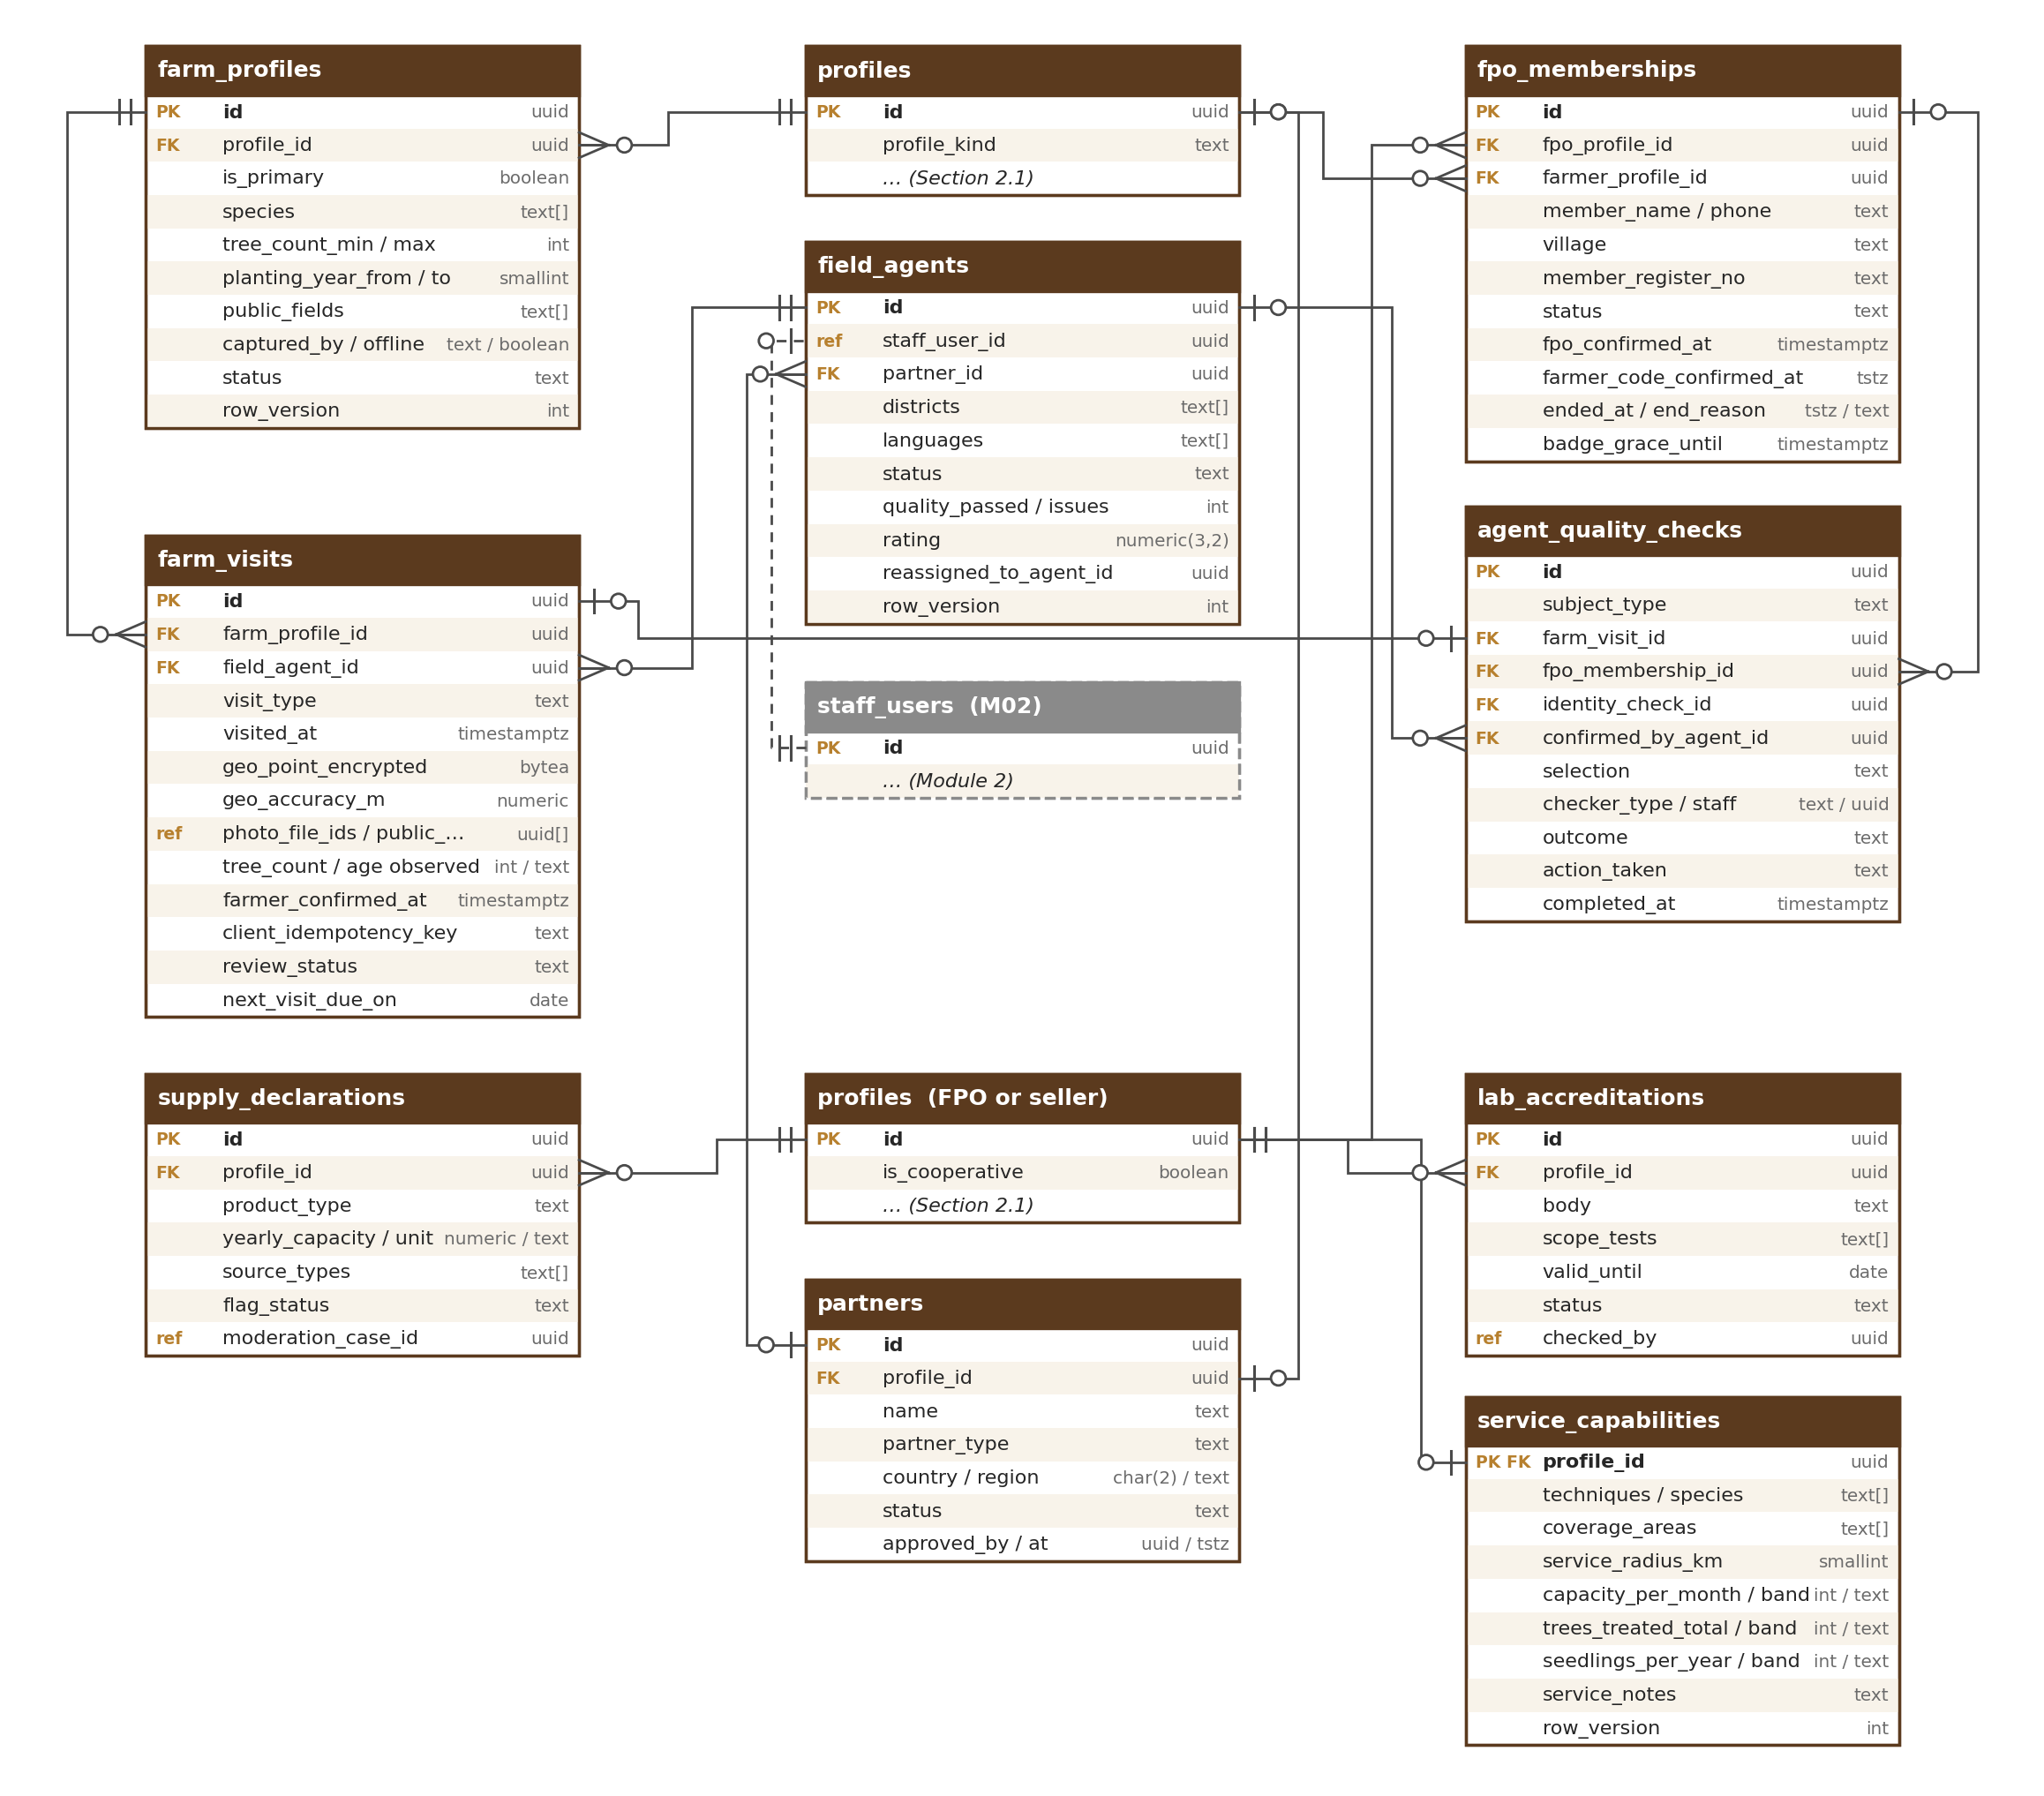
Figure 5 — Farm profiles and visits, field agents, quality checks, FPOs, partners, supply and labs

6.1 farm_profiles
A farmer’s “Your trees” — tree type, tree count range and age; optional and self-declared (FRM-001, FRM-002, FRM-021). This is the only plantation information on the farmer profile. Nothing here is needed for Verified farmer and no land document is kept here: land papers, plantation name, place and area, inoculation status, forest-department number and map pin belong to the listing (M05 / M06 hand-off). A farmer may add more than one tree group (for example two tree types); one is primary.
Column | Type | Notes
id | uuid PK
profile_id | uuid FK → profiles | Farmer profile
is_primary | boolean
plantation_name | — | Removed (25 Sep 2026): the plantation name is not on the farmer profile; asked on the listing and its trade documents (Module 5 / 6 hand-off)
district_code / region_code / country | — | Removed (25 Sep 2026): plantation place is not on the farmer profile; asked on the listing and its trade documents (Module 5 / 6 hand-off)
village | — | Removed (25 Sep 2026): village of the plantation is not on the farmer profile; asked on the listing and its trade documents (Module 5 / 6 hand-off); the farmer’s home village stays on profile_addresses (LOC-010)
geo_point_encrypted | — | Removed (25 Sep 2026): map pin is not on the farmer profile; asked on the listing and its trade documents (Module 5 / 6 hand-off)
area_value / area_unit_code | — | Removed (25 Sep 2026): plantation area is not on the farmer profile; asked on the listing and its trade documents (Module 5 / 6 hand-off)
species | text[] | aquilaria_malaccensis, aquilaria_crassna, aquilaria_sinensis, gyrinops, other, unknown
tree_count_min / tree_count_max | int / int | Ranges allowed (“about 500”); both null = not known yet
planting_year_from / planting_year_to | smallint / smallint | “Planted around 2015”
inoculation_status / inoculation_method | — | Removed (25 Sep 2026): inoculation status is not on the farmer profile; asked on the listing and its trade documents (Module 5 / 6 hand-off)
tenure_type | — | Removed (25 Sep 2026): land papers belong to the listing (Module 5/6)
forest_reg_no_encrypted / forest_reg_no_hash / forest_reg_no_masked | — | Removed (25 Sep 2026): the forest-department registration number is not on the farmer profile; asked on the listing and its trade documents (Module 5 / 6 hand-off)
land_proof_document_id | — | Removed (25 Sep 2026): land papers belong to the listing (Module 5/6)
land_proof_valid_until | — | Removed (25 Sep 2026): land papers belong to the listing (Module 5/6)
public_fields | text[] | Which of district (the farmer’s home district), species, trees, age the farmer shows publicly, always labelled “self-declared” (FRM-002, FRM-021)
captured_by / captured_offline / synced_at | text / boolean / timestamptz | farmer, field_agent; offline agent forms (FRM-012)
client_idempotency_key | text | UNIQUE when not null; makes offline sync safe to repeat
status | text | draft, active, removed (check)
row_version / anonymised_at | int / timestamptz

Data level: Public (fields listed in public_fields, shown with the farmer’s display name and labelled “self-declared”); Confidential (the rest). Retention: while the account exists. Indexes: (profile_id, status); UNIQUE partial (profile_id) where is_primary and status = active.

6.2 farm_visits
Field-agent farm-visit reports, the basis of “Farm visited” (FRM-009 to FRM-011).
Column | Type | Notes
id | uuid PK
farm_profile_id | uuid FK → farm_profiles
profile_id | uuid FK → profiles | Farmer
field_agent_id | uuid FK → field_agents
visit_type | text | first, revisit, quality_recheck (check)
visited_at | timestamptz
geo_point_encrypted / geo_accuracy_m | bytea / numeric(8,1) | GPS of the visit; a manual pin needs a reason when accuracy is worse than 100 m
manual_pin_reason | text
photo_file_ids / public_photo_file_ids | uuid[] (ref) / uuid[] (ref) | Originals are private; public copies have faces blurred (FRM-010)
tree_count_observed / tree_age_observed | int / text
inoculation_observed / notes | text / text
farmer_confirmed_at / farmer_code_channel | timestamptz / text | Farmer’s code on their own phone: sms, voice (check)
captured_offline / device_saved_at / synced_at | boolean / timestamptz / timestamptz | Offline capture (FRM-012)
client_idempotency_key | text | UNIQUE
review_status | text | submitted, approved, rejected, found_false (check)
reviewer_id / reviewed_at / rejection_reason_code | uuid (ref) / timestamptz / text | Staff screen C
face_blur_checked | boolean | Reviewer confirmed no face or home is public
next_visit_due_on | date | visited_at + 24 months (configurable)
row_version | int

Data level: Public (approved public photos, counts, month of visit); Restricted (geo point, original photos). Retention: approved reports while the account exists; rejected reports 12 months. Indexes: (farm_profile_id, visited_at desc); (field_agent_id, visited_at); (review_status, created_at); (next_visit_due_on); UNIQUE (client_idempotency_key).

6.3 field_agents
Field agents (staff realm users in M02) with regions, languages, partner and quality record (FRM-013 to FRM-015). The farmer’s delegation to an agent is identity.delegations (M02).
Column | Type | Notes
id | uuid PK
staff_user_id | uuid (ref) | UNIQUE; M02 staff_users
partner_id | uuid FK → partners | Partner organisation, or null for OudhTrade staff
districts | text[] | Districts covered (LGD codes)
languages | text[] | Languages spoken, for matching farmers (FRM-015)
status | text | active, suspended, left (check)
quality_checks_passed / issues_found | int / int | From agent_quality_checks
rating | numeric(3,2) | Quality-based rating (PRD-ROL-013)
suspended_at / suspended_reason | timestamptz / text | Proven fake confirmation suspends the agent (FRM-013)
left_at / reassigned_to_agent_id | timestamptz / uuid FK → field_agents | Farmers and drafts reassigned (FRM-014)
row_version | int

Data level: Confidential. Retention: 3 years after leaving (the audit log and farm records refer to the agent). Indexes: UNIQUE (staff_user_id); GIN (districts); (status).

6.4 agent_quality_checks
Random re-checks (default 10 %) of agent- and FPO-confirmed farmers, and all re-checks after a proven fake (FRM-013, FRM-017).
Column | Type | Notes
id | uuid PK
subject_type | text | agent_confirmation, fpo_confirmation, farm_visit (check)
identity_check_id | uuid FK → identity_checks | Route B confirmation re-checked
fpo_membership_id | uuid FK → fpo_memberships | FPO confirmation re-checked
farm_visit_id | uuid FK → farm_visits | Visit re-checked
farmer_profile_id | uuid FK → profiles
confirmed_by_agent_id | uuid FK → field_agents | Agent whose work is checked (null for FPO confirmations)
confirmed_by_fpo_profile_id | uuid FK → profiles | FPO whose confirmation is checked
selection | text | random_sample, triggered_recheck (check)
selected_at / due_on | timestamptz / date
checker_type / checker_staff_id | text / uuid (ref) | agent, staff (check); never the same agent
outcome | text | pending, confirmed, issue_found, fake_confirmation (check)
outcome_notes | text
action_taken | text | none, agent_suspended, fpo_suspended, farmers_recheck_started (check)
moderation_case_id | uuid (ref) | M12 case for a fake confirmation
completed_at | timestamptz
row_version | int

Data level: Confidential. Retention: 3 years. Check: exactly one of identity_check_id, fpo_membership_id, farm_visit_id is set (ck_agent_quality_checks_one_subject). Indexes: (outcome, due_on); (confirmed_by_agent_id); (confirmed_by_fpo_profile_id); (farmer_profile_id).

6.5 fpo_memberships
Farmers confirmed as members by an FPO or co-operative (FRM-016 to FRM-020). Rows from a member-list upload exist before the farmer signs up.
Column | Type | Notes
id | uuid PK
fpo_profile_id | uuid FK → profiles | Company with the Co-operative / FPO badge
farmer_profile_id | uuid FK → profiles | Null until the farmer joins and is matched
member_name / member_phone | text / text | From the member list; phone in E.164, used only to match and invite
village / member_register_no | text / text
source | text | member_list_upload, farmer_named_fpo, fpo_confirmed (check)
list_upload_file_id | uuid (ref) | M01 private file of the member list
status | text | listed, invited, confirmed_by_fpo, confirmed, ended, disputed (check)
confirmed_by_account_id / fpo_confirmed_at | uuid (ref) / timestamptz | FPO person who confirmed
fpo_declaration_id | uuid FK → compliance_declarations | Versioned FPO declaration (FRM-017)
farmer_code_confirmed_at | timestamptz | Farmer confirms membership by code
ended_at / end_reason | timestamptz / text | member_left, fpo_dissolved, fake_confirmation (check)
badge_grace_until | timestamptz | ended_at + 90 days for farmers verified only through this FPO (FRM-019)
row_version / anonymised_at | int / timestamptz

Data level: Confidential. Retention: confirmed memberships while either profile exists; unmatched list rows deleted 12 months after upload. Indexes: UNIQUE partial (fpo_profile_id, farmer_profile_id) where status not in (ended); (member_phone) where farmer_profile_id is null; (fpo_profile_id, status); (farmer_profile_id).

6.6 partners
Approved partner organisations: organisations whose staff act as field agents, and the OudhTrade Partner programme (R2, TRS-005).
Column | Type | Notes
id | uuid PK
partner_type | text | field_agent_org, oudhtrade_partner (check)
profile_id | uuid FK → profiles | OudhTrade Partner: the partner’s profile; null for agent organisations without one
name | text
country / region_code | char(2) (ref) / text
contact_name / contact_email / contact_phone | text / text / text
agreement_ref | text | Signed agreement
status | text | applied, active, rejected, withdrawn, suspended, ended (check); ended = removed after upheld complaints
application_text / offers / terms_version | text / text[] / text | OudhTrade Partner application: why (≤ 1,000 characters, contact details refused), what they offer (training, field_support, testing, logistics, other), Partner terms version accepted (TRS-005)
applied_at / decision_reason / reapply_after | timestamptz / text / date | Reason shown to the applicant or partner; a refused applicant can apply again after profile.partner.reapply_days
moderation_decision_ref | text | M12 decision number when a partner is removed
directory_listed | boolean | Partner Directory entry (R2)
approved_by / approved_at | uuid (ref) / timestamptz
ended_reason | text | For example upheld complaints (badge removed)
row_version | int

Data level: Confidential (contacts); Public (name of a listed OudhTrade Partner). Retention: 3 years after the partnership ends. Indexes: (partner_type, status); UNIQUE partial (profile_id) where status = active.

7. Declared Supply, Labs and Service Capability
These tables are shown in the diagram in Section 6.

7.1 supply_declarations
Declared yearly capacity and source of wood, chips and oil sellers, with the review flag (TRS-006, TRS-007).
Column | Type | Notes
id | uuid PK
profile_id | uuid FK → profiles
product_type | text | wood, chips, oil (check)
yearly_capacity / unit_code | numeric(16,3) / text (ref) | kg or litres (M01 units)
source_types | text[] | own_trees, bought_from_farmers, imported (check)
import_countries | char(2)[] | When imported
declared_at / valid_year | timestamptz / smallint
trees_estimate / quota_share_estimate | numeric(16,3) / numeric(16,3) | What the seller’s visited trees or export-quota share could give, calculated by the nightly job
flag_status / flag_reason_code | text / text | none, flagged, reviewed_ok, action_taken / above_trees, above_quota (check)
flagged_at / moderation_case_id | timestamptz / uuid (ref) | supply.flagged sent to M12; never shown publicly
status | text | current, replaced (check)
row_version | int

Data level: Confidential. Retention: 3 years. Indexes: (profile_id, product_type, status); partial (flag_status) where flag_status = flagged.

7.2 lab_accreditations
NABL or ISO/IEC 17025 certificate and scope checked before a lab is shown as “accredited” (TRS-008).
Column | Type | Notes
id | uuid PK
profile_id | uuid FK → profiles | Seller offering testing services
body | text | nabl, other_iso_17025 (check)
certificate_no | text | As printed (public on the accreditation body’s site)
scope_text / scope_tests | text / text[] | For example gc_ms
valid_from / valid_until | date / date
certificate_document_id | uuid FK → verification_documents
status | text | pending, accredited, rejected, expired, withdrawn (check)
checked_by / checked_at / check_source | uuid (ref) / timestamptz / text | nabl_directory, manual
row_version | int

Data level: Public once accredited (body, scope, validity). Retention: 3 years after expiry. Indexes: (profile_id, status); (valid_until).

7.3 service_capabilities
What a Nursery or Inoculation Provider can do: “Your capability” (TRS-014, TRS-015; PRD-ROL-040). One row per profile. Replaces the trees-per-month and seedlings-per-year values that were in profile_interests.attributes.
Column | Type | Notes
profile_id | uuid PK FK → profiles | One row per Nursery or Inoculation Provider profile (service rule checks the role)
techniques | text[] | Inoculation or growing techniques from the fixed list in the master taxonomy (M04; top-level list until then)
species | text[] | Species from the fixed list, for example aquilaria_malaccensis, aquilaria_crassna, gyrinops
coverage_areas | text[] | Districts (LGD codes), states (ISO 3166-2) or countries served
service_radius_km | smallint | Private; 1–2,000 (check)
capacity_per_month | int | Exact trees treated (Inoculation Provider) or plants dispatched (Nursery) a month; private
capacity_band | text | Public range band set by the service from capacity_per_month (bands are settings)
trees_treated_total / trees_treated_band | int / text | Inoculation Provider: trees treated so far; public only as the band
seedlings_per_year / seedlings_band | int / text | Nursery: seedlings a year; public only as the band
service_notes | text | Public notes ≤ 500 characters (check); contact details refused
updated_at / row_version | timestamptz / int | Standard

Data level: Public (techniques, species, coverage areas, the three bands, service notes); Confidential (service_radius_km, capacity_per_month, trees_treated_total, seedlings_per_year). Retention: with the profile; deleted when the role changes away from Nursery or Inoculation Provider or the profile is anonymised. Indexes: primary key (profile_id); GIN (species); GIN (coverage_areas); GIN (techniques) — for M07 filters.

8. Profile Extras, Drafts and Reminders
These tables are shown in the diagram in Section 2.

8.1 profile_interests
What I buy / what I offer (BUY-001, PRF-006). The top-level categories from the Module 4 taxonomy (six today); sub-categories from M04 when M04 adds them. M08 reads buy interests to pre-fill requirement posts; M07 uses them for suggestions.
Column | Type | Notes
id | uuid PK
profile_id | uuid FK → profiles
direction | text | buy, offer (check)
top_category_code | text | 1–6 (PRD-TAX-001)
taxonomy_node_id | uuid (ref) | M04 node once available
attributes | jsonb | Offer extras checked against M04 attribute definitions later: production type (cultivated, inoculated, processed, mixed — never wild-sourced), supply capability, export interest; Nursery seedling age range. Species, techniques, service areas, trees per month and seedlings per year are in service_capabilities (Section 7.3), not here
preferred_origins | char(2)[] | Buyers
frequency / volume_band | text / text | one_off, monthly, quarterly, ongoing (check)
added_at | timestamptz

Data level: Public for offer interests of sellers; Confidential for buyer interests. Retention: with the profile. Indexes: UNIQUE (profile_id, direction, top_category_code, coalesce(taxonomy_node_id, …)); (direction, top_category_code).

8.2 profile_links
Website and social links of sellers and farmers, shown only after verification and an ownership check (PRF-009, PRF-010, PRF-016).
Column | Type | Notes
id | uuid PK
profile_id | uuid FK → profiles
url | text | https only (check url like 'https://%'); WhatsApp, phone and messenger hosts refused by the service from a blocked-host setting
link_type | text | website, instagram, facebook, youtube, linkedin, x (check)
handle_input | text | What the user typed (a handle is turned into a full address)
scan_status / scanned_at / next_scan_at | text / timestamptz / timestamptz | pending, safe, unsafe, error (check)
ownership_method | text | meta_tag, file (websites), bio_code (social profiles) (check) (PRF-016)
ownership_token_hash / ownership_code_expires_at | bytea / timestamptz | Keyed hash of the one-time code; valid 7 days (configurable)
ownership_confirmed_at | timestamptz | Set when the code was found; with a safe scan the link shows “Link confirmed”
is_public | boolean | “Show on public profile”, on by default once the link is confirmed and safe
display_order | smallint
status / removed_at | text / timestamptz | active, removed (check)
row_version | int

Data level: Public (confirmed, safe, public links of verified profiles); Internal (ownership token hash). Retention: removed links deleted after 90 days. Indexes: (profile_id, status); partial (next_scan_at) where status = active; partial (ownership_code_expires_at) where ownership_confirmed_at is null. At most 5 active links per profile (service rule).

8.3 profile_drafts
Per-field drafts of M03 forms saved on the server (DAT-001 to DAT-003).
Column | Type | Notes
id | uuid PK
profile_id | uuid FK → profiles
account_id | uuid (ref) | Who typed (user, or field agent under delegation)
form_key | text | business_step1, business_step2, business_step3, location, farm, buyer_profile, profile_editor, capability, enhanced, role_change (check); the wizard steps and the “My profile” section forms use the same keys; also used by “Save and finish later”
field_key | text
value_text | text | Plain value
value_encrypted | bytea | Document and registration numbers (check: exactly one of the two value columns is set)
saved_at / expires_at | timestamptz / timestamptz | expires_at = saved_at + 90 days (configurable)

Data level: Confidential; Restricted for value_encrypted. Retention: deleted on submit, discard or expiry — never by a later empty visit (DAT-002). Indexes: UNIQUE (profile_id, form_key, field_key); (expires_at).

8.4 setup_reminders
Scheduled onboarding reminders (NTF-001 to NTF-004). Each row is one planned message; M13 sends it.
Column | Type | Notes
id | uuid PK
profile_id | uuid FK → profiles
reminder_type | text | unfinished_setup, missing_document, changes_needed, remote_selfie_link, reviewer_question, expiry_60, expiry_30, expiry_7, expiry_day, grace_ending, revisit_due, udyam_guide (check). land_proof_expiry: Removed (25 Sep 2026): land papers belong to the listing (Module 5/6)
related_case_id | uuid FK → verification_cases
related_ref | uuid | Farm visit or identity check the reminder is about (typed by reminder_type)
sequence_no | smallint | For example day 1, 3, 10, 30
due_at | timestamptz | Moved out of quiet hours (21:00–08:00 in the user’s time zone)
channels | text[] | email, in_app, sms, voice, agent_task
status | text | scheduled, sent, cancelled, stopped (check)
sent_at / notification_ref | timestamptz / uuid (ref) | M13 notification
stop_reason | text | done, opted_out, card_collapsed, account_not_active

Data level: Internal. Retention: 12 months. Indexes: (status, due_at); UNIQUE (profile_id, reminder_type, coalesce(related_ref, related_case_id), sequence_no).

9. Links to Other Modules
Module 3 tables hold only the IDs of records that belong to other modules (ref). There are no database foreign keys across modules. The owning module keeps the link correct through its interface and events.
Module 3 column | Points to | Owner
profile_members.account_id; role_change_requests.requested_by_account_id; authorised_persons.account_id; verification_consents.account_id; compliance_declarations.account_id; fpo_memberships.confirmed_by_account_id; profile_drafts.account_id | accounts | M02
field_agents.staff_user_id; decided_by, reviewer and checker columns; role_change_requests.recommended_by; badge_types.approved_by; identity_checks.agent_staff_id, video_call_staff_id; verification_consents.agent_staff_id; compliance_declarations.agent_staff_id | staff_users | M02
profiles.registration_country, billing_country; business_registrations.country; enhanced_checks.bank_country; profile_addresses.country; country_id_rules.country; document_checklists.country; identity_checks.id_issuing_country; partners.country | countries | M01
profile_addresses.district_code; field_agents.districts | country_districts | M01
supply_declarations.unit_code | units | M01
verification_documents.file_ids, translation_file_id; identity_checks.id_file_ids; farm_visits photo columns; profiles photo columns; profile_addresses.photo_file_ids, video_file_id; badges.evidence_file_id; fpo_memberships.list_upload_file_id; document_checklists.sample_file_id | files | M01
profile_interests.taxonomy_node_id | taxonomy_nodes | M04
sanctions_screenings.moderation_case_id; supply_declarations.moderation_case_id; agent_quality_checks.moderation_case_id | moderation cases | M12
setup_reminders.notification_ref | notifications | M13
compliance_declarations.text_version; verification_consents.text_version | legal and consent text versions (by value) | M17

Other modules point to Module 3 as follows (their designs confirm the column names):
Other module column | Points to | Module
listings.owner_profile_id; requirements.poster_profile_id; threads and quotations profile columns; subscriptions.profile_id; trust_scores.profile_id; reviews profile columns | profiles | M05, M08, M09, M10, M11
api_clients.partner_profile_id | profiles | M02
audit_log target type profile; document_links (profile) shared link | profiles | M01, M06
Listing drafts made by a field agent (agent ID, farmer profile) | field_agents, profiles | M05
Moderation cases about a profile, supply flag or agent | profiles, supply_declarations, field_agents | M12

Module 3 uses no shared-link (“type + ID”) columns across modules. Inside the module, badges.source_ref and setup_reminders.related_ref are typed by their type column and checked by the owning service; the nightly link check (Master Database Design 4.5) also covers them.

10. Retention Summary
Retention periods are registered in the Module 1 retention engine (platform.retention_policies) and run by its daily job, except the 90-day deletion of rejected and replaced documents and the selfie clean-up, which Module 3 runs itself (M03-3 Section 6). Final periods are confirmed by counsel (C10). A legal hold (M01) or an open fraud case stops deletion for the rows concerned.
Table | Kept | Then
profiles | While the account exists; hidden at once on closure | Anonymised after the M02 grace
profile_members, role_assignments, profile_translations, name_history, profile_interests | Life of the profile | Deleted or anonymised with the profile
role_change_requests | 3 years after the decision [TBC: C10] | Deleted
country_id_rules, document_checklists, badge_types | Reference data | Retired, never deleted
business_registrations | Verified: while the account is active, then [TBC: C10]; draft or removed: 90 days | Deleted
authorised_persons, beneficial_owners | Current while active; replaced or removed 3 years [TBC: C10] | Anonymised
compliance_declarations, verification_consents | Life of the profile + [TBC: C10] | Deleted; IP cleared at anonymisation
profile_addresses, profile_contacts | Active while the profile exists; removed or replaced 12 months (site photos and video deleted with the row) | Deleted
verification_cases | Life of the profile + [TBC: C10] | Deleted
verification_documents | Accepted: while the account is active + [TBC: C10]; rejected or replaced: 90 days after the decision | Files and numbers deleted; row kept as record
identity_checks | Passed: while active + [TBC: C10]; failed: 90 days; selfie never kept | Deleted
badges | Removed badges 3 years | Deleted
enhanced_checks | While active + [TBC: C10]; bank proof files deleted 90 days after the review decision (DAT-007, ENH-003) | Deleted
sanctions_screenings | 5 years after the relationship ends [TBC: C15] | Deleted
farm_profiles, farm_visits | While the account exists; rejected visits 12 months | Deleted
field_agents, partners | 3 years after leaving or ending | Anonymised
agent_quality_checks, supply_declarations, lab_accreditations | 3 years | Deleted
service_capabilities | With the profile; ends with the Nursery or Inoculation Provider role | Deleted
fpo_memberships | Confirmed: while either profile exists; unmatched list rows 12 months | Deleted
profile_links | Removed links 90 days | Deleted
profile_drafts | 90 days without change | Deleted
setup_reminders | 12 months | Deleted

11. Rules
Module 3 follows the standards of the Master Database Design (naming, IDs and UUID version 7, standard columns, data types, schema as code, safe migrations, database users). Module 3 specifics:
- Government ID, registration (including IEC) and document numbers are stored only as field-level encrypted bytea with a keyed hash (HMAC, key in AWS Secrets Manager) for duplicate checks and a masked copy for display. Map pins and visit locations are encrypted too. The Aadhaar number is never stored (check constraint on identity_checks).
- Selfies and ID photos are M01 private files, never bytea in these tables; the selfie file is deleted right after the check and selfie_deleted_at records it.
- Role and profile kind pairs are enforced by a check constraint on role_assignments; one open role change request and one current authorised person per profile are enforced by partial unique indexes.
- profiles.verification_state and the badge rows change only through VerificationService and BadgeService, in the same transaction as the case change and the outbox event (verification.decided, badge.changed).
- Status and type columns are text with a check of allowed values (no enum types). Tables edited by people carry row_version; a save on a changed record is refused (M01-2 CFG-007).
- Reference data (country_id_rules, document_checklists, badge_types) is versioned and published only through M01 ConfigService after a second approver (M03-2 DAT-012), from the Module 3 settings editors (M03-6 Sections 16.7–16.12) or by settings export and import from staging (M01-FR-ENV-008); cases keep the version they used.
- Offline agent records (identity_checks route B, farm_profiles, farm_visits) carry a client idempotency key with a unique index, so a repeated sync creates nothing twice.
- Personal-data columns are listed in the master data map and covered by retention policies (Section 10).

12. Indexes and Volumes
Main indexes and a year-1 row estimate for every Module 3 table. Every link column is indexed (Master Database Design, Section 9.3). Figures are estimates for design; load tests before R2 confirm them.
Table | Main indexes (besides the primary key) | Rows, year 1
profiles | UNIQUE (store_slug); UNIQUE (lower(trading_name)); (verification_state, verification_expires_at); partial (listings_grace_until); (registration_country); (is_public) | ≈ 60,000
profile_members | UNIQUE partial (account_id) where active; UNIQUE partial owner per profile; (profile_id) | ≈ 60,000
role_assignments | UNIQUE partial (profile_id) where active; (role, status); (role_change_request_id) | ≈ 62,000
role_change_requests | UNIQUE partial (profile_id) where open; (profile_id, created_at); (status, due_at); (verification_case_id) | ≈ 1,000
name_history | (profile_id, changed_at desc); (lower(old_value)); (verification_case_id) | ≈ 3,000
profile_translations | UNIQUE (profile_id, field, language) | ≈ 20,000
country_id_rules | UNIQUE (country, id_type, version); (country, active) | ≈ 60
business_registrations | (number_hash); UNIQUE partial primary; partial (next_registry_recheck_at); partial (next_retry_at); (profile_id, status); (country_id_rule_id); (verification_case_id); (registry_consent_id); (name_mismatch_document_id) | ≈ 15,000
authorised_persons | UNIQUE partial (profile_id) where current; (identity_check_id); (authority_document_id) | ≈ 12,000
compliance_declarations | (profile_id, declaration_type, accepted_at desc); (agent_staff_id); (related_case_id) | ≈ 25,000
profile_addresses | UNIQUE partial primary; (profile_id, status); (district_code) | ≈ 30,000
profile_contacts | UNIQUE partial (profile_id, contact_type) where active | ≈ 20,000
document_checklists | UNIQUE (role_category, country, region, slot, version); (active) | ≈ 300
verification_cases | UNIQUE (case_no); (profile_id, created_at desc); (state, fast_lane, due_at); partial (due_at); partial (expires_at); (assigned_reviewer_id, state); (renewal_of_case_id) | ≈ 25,000
verification_documents | (case_id); (profile_id, slot_key, status); (number_hash); partial (delete_after); (superseded_by_id); partial (issuing_country, lower(other_title)) where slot_key = other | ≈ 80,000
identity_checks | (profile_id, subject_type, checked_at desc); (case_id); (id_number_hash); UNIQUE (client_idempotency_key); partial (remote_link_expires_at); (consent_id); (authorised_person_id) | ≈ 30,000
verification_consents | (profile_id, check_type, chosen_at desc) | ≈ 70,000
badges | UNIQUE partial (profile_id, badge_type) where active or rechecking; (badge_type, status); (expires_at); (source_case_id) | ≈ 15,000
badge_types | PK (badge_key); (kind, active); UNIQUE (lower(name)) | < 50
enhanced_checks | (profile_id, status); (case_id); document columns | ≈ 500
beneficial_owners | (enhanced_check_id); (profile_id, status) | ≈ 800
sanctions_screenings | (profile_id, screened_at desc); partial (result) where possible_match; (batch_ref) | ≈ 20,000
farm_profiles | (profile_id, status); UNIQUE partial primary; UNIQUE (client_idempotency_key) | ≈ 3,000
farm_visits | (farm_profile_id, visited_at desc); (field_agent_id, visited_at); (review_status, created_at); (next_visit_due_on); UNIQUE (client_idempotency_key) | ≈ 2,000
field_agents | UNIQUE (staff_user_id); GIN (districts); (status); (partner_id) | < 200
agent_quality_checks | (outcome, due_on); (confirmed_by_agent_id); (confirmed_by_fpo_profile_id); (farmer_profile_id) | ≈ 500
fpo_memberships | UNIQUE partial (fpo, farmer) where not ended; (member_phone) where unmatched; (fpo_profile_id, status); (farmer_profile_id) | ≈ 5,000
partners | (partner_type, status); UNIQUE partial (profile_id) where active | < 100
supply_declarations | (profile_id, product_type, status); partial (flag_status) where flagged | ≈ 2,000
lab_accreditations | (profile_id, status); (valid_until) | < 100
service_capabilities | PK (profile_id); GIN (species); GIN (coverage_areas); GIN (techniques) | ≈ 300
profile_interests | UNIQUE (profile, direction, category, node); (direction, top_category_code) | ≈ 150,000
profile_links | (profile_id, status); partial (next_scan_at); partial (ownership_code_expires_at) | ≈ 10,000
profile_drafts | UNIQUE (profile_id, form_key, field_key); (expires_at) | ≈ 200,000 live
setup_reminders | (status, due_at); UNIQUE (profile, type, related, sequence) | ≈ 300,000

13. What Lives Elsewhere
These data are deliberately not in the profile schema. Module 3 reads them through the owning module’s interface.
Data | Where | Notes
Accounts, account state, contacts, passwords, sessions, sign-in consents, legal acceptances | identity schema and Keycloak (M02-5) | Account state and verification state are separate facts, each in one place
Delegation of a farmer to a field agent | identity.delegations (M02) | M03 calls Delegation.check before any agent action for a farmer
Staff users and roles (including field agents’ sign-in) | identity.staff_users (M02) | field_agents adds regions, languages and quality
Document, ID, selfie, photo and member-list files | platform.files and S3 (M01 file service) | Private files; 5-minute signed links; malware scan; HEIC/HEIF and WEBP conversion
Reviewer translations (calls) | platform.ai_requests (M01 AI gateway) | The translated text itself is a private file linked from verification_documents
Audit of staff views, decisions and support views | platform.audit_log (M01) | Every document view in the watermarked viewer; support views not shown to users (DAT-008)
Business hours, holidays, time zones, countries, districts, units, reserved names, store-name redirects | platform tables (M01) | Due dates and ETAs; old store addresses redirect (profile.renamed)
Rate-limit counters | Redis and platform.rate_limit_policies (M01) | M03 limits listed in M03-2 Section 15.4
Offline agent queue | The installable web app’s encrypted storage on the agent’s device | Sent with idempotency keys (M03-4 Section 10)
Setup card and the “Make your profile stronger” card | Not stored — computed live (SetupCardService) | Only profiles.setup_completed_at and setup_dismissed_items are stored (DSH-010, DSH-012, DSH-018)
Trust level and the reply measure (“Replies within 24 hours”) | M10 and M09 | Shown next to badges; not calculated by M03; from R3, M09 leaves away time out of the reply measure (PRF-018)
Land papers, plantation and origin proofs, lab reports, certificates of origin; land rights proof for land or plantation offers; a farmer’s plantation name, place and area, inoculation status, forest-department registration number and map pin | Listings and trade documents (M05, M06) | Not asked at farmer onboarding or in the enhanced check (FRM-005, ENH-002). An approved farm-visit report (farm_visits) can also be attached as proof to listings from that farm (M06); “Farm visited” stays a Module 3 profile badge
Funnel measures | M18 analytics store | Sent as events and counts; no personal data
Selfies | Nowhere after the check | Supplier deletes on completion; M01 temporary file deleted at once

